Seymour Centre
Questions and Answers from Public Meeting
Tuesday 18 January 2022
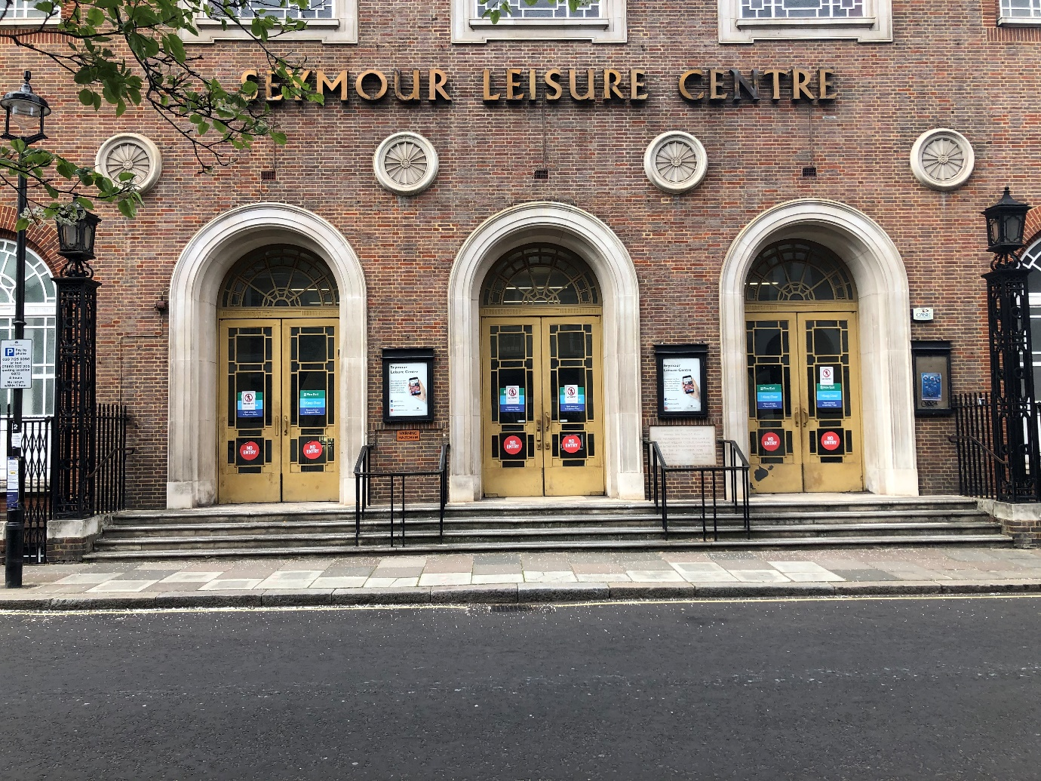
The council is committed to delivering high-quality community spaces and services within the Seymour Centre. We want to ensure that we are hearing what the local community would like from this building, as we incorporate a new library, provide a better leisure centre and use the space to provide wider services for you.

On Tuesday 18th January we held a public meeting where we shared the feedback from the community consultation and our initial ideas for the improvement project. During the meeting we invited attendees to ask questions and where possible the team answered these during the session.

Please find below table questions that attendees asked at the public meeting:

Questions | Answers
GENERAL
What covid measures are being taken. I have not re-joined as yet? | If you contact the Seymour Leisure Centre directly, they will have the latest guideline on the measures that are in place. The information is also on their website https://www.everyoneactive.com/centre/seymour-leisure-centre/
When is planning submission intended? | The planning application will be submitted later this year following design development and community consultation.
We have heard that you will add a new floor and why isn't that happening? | We have had very clear guidance from the planning officers and Historic England that inserting a new mezzanine floor into the main hall space would not be acceptable.
I am blind. Physical accessibility is not enough. The gym is currently impossible for me to use alone. What will be done to improve this for me and other disabled people? | We will be working very closely with an accessibility consultant to ensure the design of the building and its facilities are as accessible as possible. We will also be working with the ABLE Network which is a group of council staff who have a wide range of disabilities or long-term conditions. Finally, we will be encouraging all users and potential users to get involved with the detailed consultation events so that we can incorporate all feedback.
Overall, the scheme puts a lot more on community activities but in a way which is not proven to work in any other London building I am aware of - do you have any examples of multi-use centres which try to meet all these objectives and are they really successful, the underlying issue being are you biting off too many functions than you can chew? | There are many examples of successful community hubs similar that proposed at Seymour Centre including The Plumstead Centre, The Eltham Centre and The Westcroft Centre (links below)  https://www.better.org.uk/leisure-centre/london/greenwich/the-plumstead-centre  https://www.better.org.uk/leisure-centre/london/greenwich/eltham-centre  https://www.everyoneactive.com/centre/westcroft-leisure-centre/
And in that regard have you budgeted the manpower, maintenance and health and safety and security aspects of all these spaces and rooms and who will be responsible for that, bearing in mind maintenance and cleanliness is not now nor has ever been a hallmark of our otherwise highly valued centre? | The management of the Centre will need to change as it will house different uses and not just leisure. We know that the management will need to be proactive, and we intend to learn from the management of other similar Centres referenced above and wider.
Given the multiple demands and new facilities that you are looking to accommodate, how will you avoid giving everyone a mediocre offering to every user rather than trying to provide excellent facilities for a few users here and then look to provide other facilities elsewhere? | We are looking to implement a similar mix of facilities that are proven to be successful at other exemplar Community Hubs in London such as The Plumstead Centre, The Eltham Centre and The Westcroft Centre.
Is it planned that the centre will continue to be used for events (such as Fashion Week} which can be very loud and disruptive to residents that live close to the centre? | The aim is to continue with events. We take note of this feedback and will ensure that our plans include for events to be mindful and respectful of adjacent residents.
When are plans and documents going to be available and why were they not available before this meeting? | The plans and documents will be on the dedicated website.
How will regular users of the centre be accommodated whilst they are unable to use it? | Regular users will be signposted to alternative facilities during the construction period
When you say Sport England guidelines, at what level? Club, International? Community etc. This is important. | We will be engaging closely with Sport England to establish what level can be achieved for each sport.
How long is the pool likely to be closed for the refurb? | The entire centre will be closed throughout the duration of the construction phase. This is likely to be 18 - 20 months as it is a major transformation.
Will the proposals be sent to us and/or displayed at the Centre? | The proposals will be uploaded to the dedicated website, displayed at the Centre, and displayed at other community venues including Marylebone Library.
Current facilities are not great in terms of ventilation during pandemic. How will this be improved? | The heating and ventilation strategy for the whole building will be reviewed and upgraded as part of the project.
Why are you still considering a cafe which will be in competition with the many cafes across the street? | The community survey strongly indicated the need for a café/refreshment space within the building particularly by parents whose children use or would use the Centre. This will be tested as part of the Business Case.
It was said that changes in design had been made because of Covid. What are these? | The aspiration for the building as a multi-service community centre is a covid response. By enhancing the existing leisure services and combining these with other services such as the library, family spaces, café and flexible community spaces the building will be an asset not only to its existing users but also a much wider and diverse cross section of the local community.
LIBRARY
Why does the library need to be incorporated into the leisure centre? What will be done with the existing library? | The existing Library lease will end and the council has long promised to have a substantive permanent Library in the Marylebone area and this project will uphold that promise. There is a lot of "dead" space within Seymour Centre which is currently not publicly accessible. We want to make better use of the space by incorporating a number of services which complement each other such as children’s library, soft play area, facilities for parents etc. The 'vision' is to create a community space/hub offering a range of services within a single facility.
given the timeline to open in 2025, is there space to house a library in the Marylebone area til then? | The aim is to retain Marylebone Library in its existing temporary base at New Cavendish Street.
It looks like adding the library will compromise the sports facilities. | We disagree. The plans are still in development, however we will ensure that there is a good balance of areas between all the uses proposed at the centre. As stated before, there is a lot of space in the Centre which is currently either not used or under-utilised.
SPORTS HALL
What height will the sport's hall be? | The sports hall currently supports competitive badminton play and training for up to Junior County level players. Based on Sports England Guidelines, an unobstructed height of 7.5m is required to meet the guidelines applicable to this usage. Sport England has different guidance depending on type of usage. Club level minimum would be needed to support current usage.
Why are you downgrading the sports hall to 4 four courts? | The Sports Hall will not be downgraded - 5 courts will remain. Thanks for the feedback on this point.
As there will be a first floor on top of the sport hall, the height of the sport hall won't work for badminton, how do you think badminton could go on at Seymour? | The Sports Hall will remain as it is currently. There is no mezzanine proposed.
SWIMMING POOL
What size would the pool be? | We are taking Sports England Guidelines on the length and the width of the pool. We are currently looking at different options for the pool as nothing has been agreed yet including the pool depth.
Earlier plans showed the main pool being reopened (under sports hall). This plan shows pool where it is. Early referb design suggested pool being uniformly 1m deep. this would make the pool useless for scuba training - what are the latest designs/intentions for the pool? | We will be engaging with the clubs to understand in more detail about what is required and how we can facilitate that, both at an operational and functional level. The depth of the pool hasn’t been decided yet, we are exploring several options such as new tank, relining the existing tank etc.
How long is the man pool and in comparison, to the current pool and why you didn’t' bring back the old main pool | We explored reinstating the main pool. However this was discounted as there is no other space big enough in the building to accommodate a usable sports hall.
Why was the pool not enlarged (with more lanes) and created a better swimming facility like done in Swiss Cottage and Moberly Sport Centers? Pools have been removed in the recent years from the area | See above
There are national level young athletes in Westminster who do not have access to suitable pool space to train. Swiss Cottage is used by a Camden club and there is not enough space at Moberly. Do not replace pool space with libraries and community rooms. Use empty offices for that. | There are no plans to replace the swimming pool space with library or community space. The swimming pool function will remain an important element of the facilities on offer at Seymour.
CLUB FACILITIES
Very exciting plans for the Seymour; thanks for sharing. A question about the club space: will the new design accommodate the current club tenants with substantially similar allocations of space? | We are yet to decide on the space for clubs as this is the next phase of engagement; namely to understand the needs of each club. Our intention is to retain the existing clubs and to improve and enhance facilities.
Hello, the scuba club is located next to the squash but does not appear on your plan? | We are looking to create shared bookable meeting space for club use with dedicated lockable storage areas for each club.
Is the club space detailed here a new club room for the scuba club? You are making much of the architectural history of the building and Seymour has been the home of Scuba Diving in the UK since 1953. | We are aware of the building being home to Scuba Diving for a long time. We will be engaging with all clubs as we certainly don't want to lose valued users.
GYM
why do you think fitness rooms underground in a basement will be attractive – it’s hardly a norm - please explain | Currently the fitness facilities are located over a number of floors and in disparate locations within the building. By utilising the large space beneath the sports hall and adjacent spaces on the lower ground floor, we can offer a consolidated fitness service which incorporates fitness suite, spin, flexible studios, martial arts space, club space, climbing & bouldering as well as treatment rooms, spa and high quality changing facilities all on one level. Some of these spaces have access to natural light via the lightwells around the perimeter of the building. All spaces will be mechanically ventilated and daylight LED fixtures will ensure all spaces, even those without access to natural light, will be bright and evenly lit.
Will sharing of space mean reduction in number of fitness classes (- already drastically reduced)? | Sharing of spaces will mean more efficient use of space within the building according to demand. We will pass on your comment about drastically reduced fitness classes to the Centre Manager.

