Project Execution Plan
AC109 Millbank FRA Works

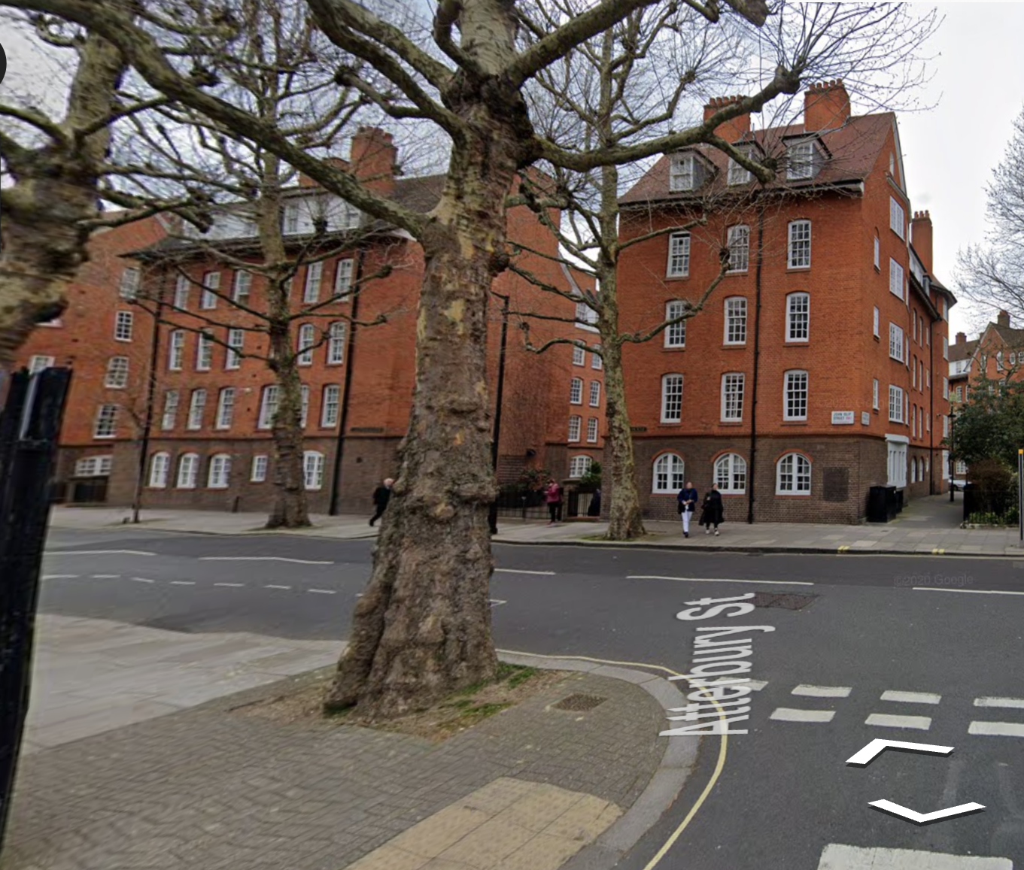

UL Contract number; AC109
Version control
Revision | Date | Prepared by | Authorised by | Director Approval | Details
0 | 03/05/2023 | JH
1

Distribution details: Note this document is subject to revision until approved by Westminster City Council and a Pre-Commencement Order is issued. Previous revisions will be retained for archive.

Contents

- Introduction

- Scope of Work and observations

- Design Strategy

- Programme

- Resource Plan and Preliminaries

- Cost Plan

- Information Required

- Communication Plan

Appendix A - Programme
Appendix B – Budget
Appendix C – Scope Of Works
Appendix D – Request for Information Schedule

- Introduction

  - Scheme Background
This Project Execution Plan (PEP) has been developed from the WCC Client Brief, AC109, for a project of fire safety works to seven blocks on the Millbank estate.

  - Purpose

The intention of this PEP is to capture and record the strategy for design, procurement and delivery of each task set out in the client brief, including a detailed programme and resource plans for delivery, identification of any risks for mitigation and any added value or alternative methodologies for consideration. This PEP will be subject to further review, discussion, and agreement with the client team to enable a pre-commencement order to be issued for the development of detailed Service Provider Proposals (SPP)

  - Property Addresses/ Location
Block Name | No of Units | No of Leaseholders
Landseer House, SW1P 4EB | 25 | 16
Lawrence House, SW1P 4ED | 39 | 20
Leighton house, SW1P 4HT | 15 | 7
Rossetti House, SW1P 4DZ | 30 | 26
Ruskin House, SW1P 4HU | 55 | 25
Stubbs House, SW1P 4DY | 30 | 14
Turner House, SW1P 4DZ | 60 | 26
TOTAL | 254 | 134

1.4 Property Descriptions (from Client Brief)

Landseer House
Landseer House is a five-storey residential block containing 25 flats. The date of construction is 1906. The block is located on John Islip Street and extends into Herrick Street. The building has two street access that leads to the courtyard, one from John Islip Street and the other is from Herrick Street. The block is served by two staircases which exits into the courtyard. The external walls are of solid brick construction. The roof is pitched and covered with tiles together with lead lined dormer windows.

Lawrence House
Lawrence House is a five- storey residential block containing 39 flats, and the date of construction is 1906. It is located on the junction of John Islip Street and Cureton Street. The building has two street access that leads to the courtyard, one from John Islip Street and the other is on Herrick Street. The block is served by three staircases which exits into the courtyard. The external walls are of solid brick construction. The roof is pitched and covered with tiles together with lead lined dormer windows.

Leighton House
Leighton House is a five- storey residential block containing 15 flats, and the date of construction is 1906. It is located on the junction of John Islip Street and Atterbury street. The building has two street access that leads to the courtyard, one from John Islip Street and the other is on Herrick street. The block is served by a single staircase which exits into the courtyard. The external walls are of solid brick construction. The roof is pitched and covered with tiles together with lead lined dormer windows.

Rossetti House
Rossetti House is a five- storey residential block containing 30 flats, and the date of construction is 1906. It is located on the junction of St Oswulf Street and Erasmus Street. The building has two street access that leads to the courtyard, one from John Islip Street and the other is on Herrick Street. The block is served by three staircases which exits into the courtyard. The external walls of the first four stories are predominantly of solid brick construction and the top floor of solid painted render. The roof is pitched and covered with tiles.

Ruskin House
Ruskin House is a large five storey residential block containing 55 flats, and the date of construction is 1906. It is located on the junction of St Oswulf Street and Herrick Street. The building has two street access that leads to the courtyard, one from St Oswulf Street and the other is on Erasmus Street. The block is served by four staircases which exits into the courtyard. The external walls are of solid brick construction. The roof is pitched and covered with tiles together with lead lined dormer windows.

Stubbs House
Stubbs House is a five-storey residential block containing 30 flats, and the date of construction is 1906. It is located on the junction of St Oswulf Street and Erasmus Street. The building has two street access that leads to the courtyard, one from St Oswulf Street and the other is on Erasmus Street. The block is served by three staircases which exits into the courtyard. The external walls of the first four stories are predominantly of solid brick construction and the top floor of solid painted render. The roof is pitched and covered with tiles.

Turner House
Turner House is a large five storey residential block containing 60 flats, and the date of construction is 1906. It is located on the junction of St Oswulf Street and Herrick Street. The building has two street access that leads to the courtyard, one from St Oswulf Street and the other is on Erasmus Street. The block is served by four staircases which exits into the courtyard. The external walls are of solid brick construction. The roof is pitched and covered with tiles together with lead lined dormer windows.

- Scope of Works
The scope of works identified in the Client Brief and UL observations are tabled below:

- Design Strategy
We set out below our design strategy for the tasks and services required to fulfil the description of works detailed in the Client Brief. We have identified the necessary services to develop the detailed design, prepare documentation to demonstrate competitive pricing, submit applications to obtain statutory consents, all as required to create our Project Proposals Document following receipt of a Pre-commencement Order.

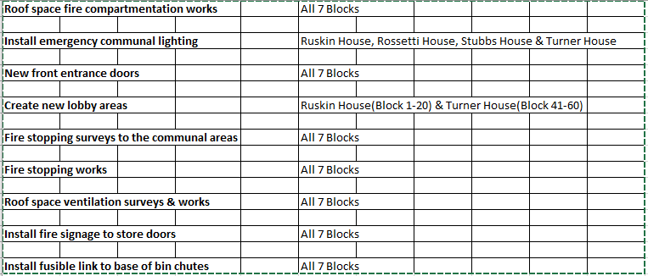

Element | Design Process | Item | Discipline/  Responsibility | Level of Detail Currently | Level of information Required(See Stage) | Design Stage RIBA 3/4
Condition Survey | SURVEY | Pre-existing information regarding the condition of the building and associated ancillary areas has been provided in the IPCI in Appendix 1. | CLIENT | FULL | Blocks: All  The PD where appointed (or PC where no PD duty holder is in place) is to inform the Client, where additional survey or inspections are required to develop the PCI and inform the design process.  The PC is required to complete a pre-commencement condition survey within all areas likely to be affected by the works, which shall contain written and photographic evidence of the existing conditions.  The PC is to identify any areas of concern that may result in additional works being necessary, together with proposed remedial recommendations, within the scope of works. The condition survey is to be agreed with WCC/WCCs Client Representative and upon conclusion of the works the PC is to ensure the condition of any areas affected by the works are handed over to WCC/WCC in no worse a condition than at pre-commencement stage. | Stage 4
Access Required | SURVEY | Site Investigation Report | SPECIALIST SUB- CONTRACTOR | Client Brief | Blocks: All  The PC is to ensure that all work at height activities is risk assessed and that the proposed method of access to facilitate the works is detailed in the CPP and fully costed in the PEP.  Should there be any reason that specific access arrangements cannot be fully evaluated and costed for then the Service Provider should identify these together with a defined Provisional allowance within their PEP for each specific item/ area.  Access will be needed to the tenanted properties to renew the front entrance doors. | Stage 4
Electrical Lighting | Survey |  | SPECIALIST SUB- CONTRACTOR / ARCHITECT/LD (Product Design) | Client Brief | Blocks: Rossetti House, Ruskin House, Stubbs House & Turner House.  Replace existing lighting in the communal areas with LED lighting. The new systems to comply with current regulatory requirements and CIBSE recommended levels (minimum illumination of 200lux in all plant room spaces required).  The Lighting installation is to include emergency lighting provisions in accordance with BS 5266 Emergency Lighting requirements.  Provide Electrical Installation Certificate (EIC) and all appropriate certification associated with The Works undertaken. | Stage 4
Bin Chutes |  |  |  |  | Blocks: All  - Install fusible link to base of bin chutes.  Blocks: Landseer, Lawrence, Leighton, Ruskin, Rossetti & Turner House.  - Replace bin chute hopper heads.  The service provider should ensure the installation conforms with the British standards. | Stage 4
Fire Safety Works | FIRE PROTECTION | Fire Stopping through Compartment Floor  Barriers: above ceilings (voids)  Circulation  Fire Stopping (walls/ducts/cables) Fire Strategy (ARCH/LD) | ARCHITECT/LD - SPECIALIST SUB- CONTRACTOR | Client Brief | Blocks: All  - Fire stopping surveys to communal areas.  - Fire stopping works in communal areas.  - Install FDKL signage on store doors.  - Roof compartmentation –The service provider should try to achieve 60 minutes protection. Information from similar projects on the estate suggests there might be need for ventilation works in the roof spaces after the compartmentation works. The service provider should carry out further investigations to the roof space to determine if there is adequate ventilation and report findings to the WCC representative confirming ventilation works are required or not necessary. Provisional costs for the ventilation works have been allowed for. Any works to comply with Part B of the building regulations if required.  The service provider should review the fire risk assessment report to ensure familiarisation to all areas affected by the works. Identify all works deemed necessary and associated with the works to ensure all fire safety requirements are met.  Report findings with respect to recommendations to WCC for any additional work that may be deemed appropriate with regard to fire protection matters for consideration and further direction/instruction.  Ensure the works are fully compliant with all current regulatory requirements.  Following recommendations from the site survey and compartmentation report carry out all passive fire protection. All passive fire protection and door installation works must be undertaken by a Competent Person. The term competent person shall mean a person or business who has demonstrated to a Third Party that they have the expertise, skills and commitment in the identification and installation of passive fire protection and fire door installation. The term Third Party shall mean a Certification body accredited by the United Kingdom Accreditation Service (UKAS).  All fire safety materials, doorsets and doors shall be Third Party certificated fire stopping products where Third Party shall mean a Certification body accredited by the United Kingdom Accreditation Service (UKAS). All products used shall be delivered with the relevant certification for inspection.  A full report should be provided on completion of the works, to include photos of pre- and post-condition as part of the ‘Condition Survey’ element of works. Upon completion of the works Regulation 38 shall be complied with and this is a requirement under the Building Regulations for England and Wales to provide fire safety information to the 'responsible person' at the completion of a project, or where the building or extension is first occupied.  Note – All fire safety works are to be undertaken by an accredited third party of an appropriate ‘industry recognised’ body. A full report should be provided on completion of the works, to include photos of pre- and post-condition as part of the ‘Condition Survey’ element of works. | Stage 4
Fire Door Works | FIRE PROTECTION - INTERNAL WALLS AND INTERNAL FINISHES | Doors/Glazing Schedules | ARCHITECT/LD | Identification from Stage 3 reports for fire strategy ARCH/LD and Fire Engineer | Blocks: All  The service provider is to carry out fire door set works to all flat entrance doors to tenanted properties only and the newly created lobby areas as set out in the fire door schedule of works located within Appendix 7. This includes service intake cupboard doors and service riser doors to some bocks.  The service provider has carried out a further fire door inspection to every private flat entrance door that opens onto the communal area and escape route by a competent person suitably qualified to do so including, but not limited to, BM TRADA Q-Mark Installer Certificate, Fire Door Inspection Scheme (FDIS) Certificate and IFC Certification Ltd (IFCC). The inspection and detailed report provided on the condition of the fire door, its integrity, any certification it has, comments on the installation, condition and compliance of the door itself and of any ironmongery fitted to it has been detailed for replacement to FD30S standard as specified and included in Appendix 7.  All fire door set replacement are to be undertaken by an accredited third-party installation company of an appropriate ‘industry-recognised’ body in accordance with the manufacturer’s instruction, industry recognised best practice and BS 8214:2016. Gaps between the frame and aperture should be adequately filled with intumescent materials suitable for the task. A full report should be provided on completion of the works, to include photos of the installation process to each property. Leaseholders will be given the option to replace their front entrance door at an additional cost.  It is expected that doors and door sets will comply fully with the WCC Fire Door Performance Specification contained in Appendix 7.  All fire door sets and doors shall have FSC chain of custody or PERF COC certification. | Stage 4
Windows |  |  | Specialist Contractor | Client brief | Ruskin House (Block 1-20)  Replace the glass pane to 5no- internal flat windows with fire rated glass pane (Flats 3, 7, 11, 15 & 19). The service provider should ensure the new installed panes have 60 minutes EIR protection. The installation must be certified by the installer.  Installation to be compliant with current building regulations and approval gained. | Stage 4
Create New lobby areas |  | Specification |  | Client Brief | Blocks: Ruskin House (Block 1-20) & Turner House (Block 41-60).  Create five new lobby areas for each of the two blocks in the dog-leg corridors coming off the main staircase enclosure at each level leading to flats. Install 5 number glazed FD30S SC door sets at each new lobby area created.  The materials used to create the new lobby areas must be fire resistant materials.  The service provider should ensure residents are informed before the work starts and engage with WCC Fire team before starting construction of the new lobby areas. Furthermore, it is critical that WCC Building Control are involved at the early design stage for input and consultation.  Following agreement and completion, Service Provider is to produce floor plans for the blocks showing the new layout with the newly installed lobby areas.  See drawing in Appendix 7 and FRA report on Shine. | Stage 3
Asset Tagging |  |  | SPECIALIST SUB- CONTRACTOR | Client Brief | Blocks: All  Appoint an asset tagging company (Mitags or approved equivalent) to supply, install and carry out the installation, programming, and commissioning of asset tags to new items upon completion of works.  All main plant & equipment components associated with the works are to be scheduled by the Service Provider within their PEP. The Service Provider is to provide a proposed Asset Tagging Register of all components for review and approval by WCC | Stage 3
Asbestos Management | SURVEY | Access Shine | Client | Client Brief | Blocks: All  Contractor to note that all live asbestos information can be found on the Westminster City Council asbestos portal, Shine. The PD/PC is required to inform the client regarding the need to instruct any further R&D surveys as the design develops and the areas where intrusive works will be required are confirmed. The R&D survey will be instructed by the client through the asbestos management system and provided to the PD/PC as part of the PCI, to allow the CPP to be developed. The Service Providers Project Execution Plan needs to identify any further works, with estimated costs, for completing removal or encapsulation of ACMs to enable The Works. The SP is to ensure that any subcontractor undertaking asbestos removal works as part of The Works, fulfils the client’s requirements outlined in the WCC process and procedure documents and are deemed competent to undertake the required works.  The SP is to ensure that any subcontractor undertaking asbestos removal works as part of The Works, fulfils the clients licence requirements and are deemed competent to undertake the required works. | Stage 5
Other Potentially Hazardous Circumstances | SURVEY | Specification(s) | SPECIALIST SUB- CONTRACTOR | Client Brief | Blocks: All  Where held the Client has provided relevant information regarding the existing structure(s) and materials in the IPCI.  The PD/PC is to inform the client if during the design stage, it becomes evident that there is the potential for other deleterious materials or hazards to be present and further inspection or testing is required.  Other materials that may be present or that need considering include but are not limited to:  - Lead Paint  - HAC  - Horse hair plaster  - Clay pot floors  - Calcium silicate brickwork  - RAAC planks  - Tesserae  - Vermiculite  Other hazards that may be present:  - Fragile roof materials  - Unprotected roof lights  - Unprotected flat roofs  - Unprotected fall risks (shafts/ sumps)  - Confined spaces  - Insufficient safe access provision to plant and equipment  - Noise protection zones | Stage 3
H&S File and O&M Manual |  | Specification(s) | Consultant | Client Brief | Blocks: All  These buildings do not currently have a H&S file.  Create/provide a new Health and Safety File and Operating & Maintenance manuals for the building and also for all systems associated with The Works. The file shall be in accordance with and as detailed within the Term Partnering Contract. This is to include but is not limited to;  - A detailed future Planned Preventative Maintenance (PPM) programme/ regime associated with The Works;  - As-built drawings, specifications, schematics, schedules etc.  - Manufacturers details, guarantees and warranties (as applicable)  - Details of risks and hazardous materials not eliminated through design.  - Site Investigation Reports  - Statutory authority consents and approvals | Stage 5
Maintaining the existing building services |  | Specification(s) | SPECIALIST SUB- CONTRACTOR | Client Brief | Blocks: All  Maintain the building services systems during the duration of the contract. Where services may not be functioning or operational for a period of time prior notice and resident notification shall take place. | Stage 5

  - Statutory Approvals

This scheme is located within the Millbank conservation areas, and are Grade II, listed therefore we will liaise with the WCC Conservation Officer on the following elements of the proposed scope of works:

- Addition of lobby areas to Ruskin House and Turner House
- Fire door Installation
- External Lighting Design

Planning consent will be sought for, following supplier surveys and issue of design proposals.

It is not envisaged that water or gas services will need to be adjusted however electrical incoming supply loads will be checked during the electrical inspections.

For the purpose of this PEP it has been assumed any necessary permissions will be granted.

  - Design Strategy for Each Element

Design responsibilities are identified within the Term Contract. All works will be undertaken in accordance with UK/ EU current standards and regulatory/ statutory requirements.

All information provided to United Living by WCC is issued for information purposes only and does not form any part of the United Living design. Should we (UL) wish to engage with any third party previously employed by the client, we will seek permission from WCC directly.

Our design information will include but is not limited to, the following:

- Drawings, including general arrangements (plan layouts), sections and elevations, detail drawings (at appropriate scales), schedules and schematics in advance of commencement agreement.
- Material and workmanship specifications in advance of commencement agreement.
- Calculations and equipment selection rational (including relevant technical submittals) to be agreed with WCC during the pre-commencement stage.

General guarantee/warranty and design expectations for all materials and equipment are as follows:

- Product failure liability cover.
- Consequential damage cover to building fabric and contents where a product has failed
- Workmanship of Service Provider
- Design liability for the contents of the system supplier’s specification, advice and any other detailed drawings supplied.
- Specification for all materials including investigations of substrates and suitability of appropriate product.

Values of cover and parameters of guarantees and warranties will be presented to the Client Representative with the United Living business case for the works.
The table below outlines the key expectations of WCC for general materials and design. United Living will review these and agree preferred manufacturers / suppliers at pre-commencement stage
WCC Material Design Requirements – Millbank FRA AC109
Element | Design Requirements | Guarantee / Warranty Requirement | Pricing Methodology
Decoration | All substrates to be tested for damp and other contaminants such as lead, asbestos etc. to ensure suitable for application of paint. Site specific specification to be provided | 10 Years | SOR
Decoration (Class 0) | Cross cut paint samples to show paint adhesion carried out by specialist prior to specification. All substrates to be tested for damp and other contaminants to ensure suitable for application of paint. Site-specific specification to be provided. | 10 Years | SOR
Windows (Timber) | Detailed drawings and windows schedules and site-specific specification will be provided and made available to the Contractor. FENSA or equally approved certification. | 10 Years | Business case
Fire Doors / Front Entrance doors (FEDs) | All Door sets to be third party certified and for FED certified as Secure by Design (SBD). All to meet requirements of CWH Fire Door Performance Specification. Door schedule to be provided and included within FRA plan. Contractor must note planning restrictions where installing doors in conservation areas or to listed buildings. | 20 Years (10 years for ironmongery) | Business case
Concrete Repairs | Each repair to be identified on elevation plan, backed up by itemised spreadsheet – all repairs to be signed off by Client representative. | 10 Years | SOR
Timber Repairs (resin) | Each repair to be identified on elevation plan, backed up by itemised spreadsheet – all repairs to be signed off by Client representative. | 10 Years | SOR
Light Installation | Full site-specific proposals to current standards, British Standards, CIBSE guidance and regulations. Layout and wiring/ circuit drawings, schematics, specifications, fittings schedules, technical submittals and calculations to be provided and agreed at pre-commencement stage. Minimum of IP65 rating. Key switch provided for testing. | 5-year manufacturer’s warranty | Business Case to be provided where SOR cannot be applied
Electrical Fittings Generally | Full site-specific proposals to current standards and regulations.  Layout and wiring/ circuit drawings, schematics, specifications, fittings schedules, technical submittals and calculations to be provided and agreed at pre-commencement stage. | Standard manufacturer’s warranty | Business Case to be provided where SOR cannot be applied
Access Doors/ Hatches/ Ladders | Full site-specific proposals to current standards and regulations.  Layout drawings, construction details (sections and plans), Door/ Hatch schedules, Ironmongery schedules (including signage details), specifications and technical submittals to be provided and agreed at pre-commencement stage.  Hatches and doors to be manufactured in aluminium with polyester powder coated finish. Hatches to comprise gas spring assisted opening lid supported by heavy-duty stainless steel hinges. Hatch to be fully insulated. | Minimum 10 years manufactures warranty | Business Case to be provided where SOR cannot be applied
Builders work in connection (BWIC) including decorative works and fabric repairs | Full site-specific proposals to current standards and regulations.  BWIC Layout detail drawings and specifications to be provided and agreed at pre-commencement stage. | N/A | SOR
FRA works | Full site-specific proposals to current standards and regulations.  Fire Strategy Report & Drawings (if required), Layout Drawings and Details, Specifications and Technical Submittals to be provided and agreed at pre-commencement stage. | Standard manufacturer’s warranty | Business Case to be provided where SOR cannot be applied

  - Design Process including Quality Checking and Monitoring Arrangements

The United Living design team will:

- Ensure the Client Team is fully engaged in the design processes. WCC will be invited to all design workshops, review meetings and formal design team meetings to ensure requirements are met.
- Develop a realistic design programme linked to procurement and construction requirements.
- Understand WCC requirements, project brief and key issues for stakeholders.
- Undertake value engineering to find the optimum cost value design solutions.
- Promote a team ethos with collaborative communication and knowledge sharing.
- Implement regular design meetings and workshops using the “United Way” a structured framework of procedures to provide consistency of delivery.
- Monitor progress of design tasks/stages using our design management tracker.

Design solutions will be considered for:

- Compliance with Client Brief
- WCC requirements and statutory controls
- Value engineering opportunities, streamlining processes, repair/maintenance costs.
- Life cycle cost economies e.g., product selection, guarantees, material durability;
- Sustainability - product longevity, social sustainability, social value.
- Risk mitigation (designing out risks and development of Risk Register)
- Best cost and value solutions
- Safe systems of work

Design compliance, quality checking and monitoring procedures will include:

- The appointment of consultants and specialist subcontractors competent for their role.
- Subcontract and scope of service agreements will be aligned to the main partnering contract.
- Checking collateral warranty agreements and professional indemnity insurances are in place at the required levels.
- Design review checklist - to identify design conflicts/gaps and used to inform risk register.
- Design start up meeting to review design tasks, agree key stage client sign off for design development
- Establish design responsibility matrix.
- Identify immediate key deliverables e.g. preparing planning application; investigative surveys;
- The design manager will use the UL management tracker to coordinate both consultant and subcontractor design input and to provide key dates for issue of information.
- Regular design team meetings will monitor progress against the design programme, including:

- Planning applications
- Surveys.
- Preparing specifications for business case tendering
- Reviewing compliance with client requirements
- Reviewing the design risk register.
- Value engineering opportunities

3.4 Survey Summary
Surveys identified to date to establish final scope of works and costs are as follows:
Condition review of all current roof doors, hatch provisions, and access requirements | UL Specialist | Pre-commencement stage. To be finalised with WCC when on site
Replacement Glazing | UL Specialist | Accessible areas at pre-commencement stage. Non accessible areas when access equipment available
Previously painted surfaces | UL | Pre-commencement stage
FRA | UL Specialist | Pre-commencement stage
Electrical- emergency lighting | UL Specialist | Pre-commencement stage
Ventilation to roof space | UL Specialist | Pre-commencement stage
Asbestos R&D / other hazards | UL Specialist | Pre-commencement stage

- Programme

A programme of works has been created and can be found within Appendix A. In summary the construction phase of the project has been estimated at 33 Weeks.

5.0 Resource Plan and Preliminaries
It would be possible to have a shared compound with the existing scheme at Millbank S159, if you feel that this has been at this location for long enough, we could set up within the courtyard between the blocks on this scheme.

5.1 Project Management Structure

5.2 Subcontractor Supply Chain:

- FRA surveyor
- Door manufacturer/Installer
- Window repair specialist
- Electrical design engineer
- Electrical contractor
- Asbestos surveyor
- Asbestos removal specialist
- Decorating specialist
- Carpenter

5.3 Site Setup Proposal

At all locations, it will be necessary to apply for parking bay suspensions to locate waste skips close to the sites and to enable deliveries of materials.

Our site set up proposals for the project will be expanded on in detail in the SPP, including exact location, phasing, types and numbers of temporary units and material delivery / distribution arrangements.

6 Cost Plan

United living has reviewed the scope of works as defined within section 2, carried out site visits and liaised with various sub-contractors.

A detailed breakdown is included within appendix B.

- Information Required
Appendix D includes a request for information schedule that will be continually updated throughout pre-construction and construction phases.

- Communications Plan

Our strategy for communication with the local stakeholders will be to:
- Identify all those who are likely to be impacted by the project.
- Confirm party wall survey arrangements.
- Liaise with the WCC neighbourhood offices concerned.
- Check for any nearby schools and nurseries.
- Ensure each stakeholder has been directly communicated with and fully understands what is proposed and how they can communicate with us if they have any concerns.
- Set up project specific newsletter format for updating stakeholders on progress.

During our initial surveys of the area, we have started to identify if there will be any community stakeholders who will be affected by the works, the design of the blocks are quite unique where all entrances come off a central courtyard so any work to the blocks will only effect the same residents of that particular block, so nobody externally will be affected.

Our Resident Liaison Manager (RLM) will allocate a trained and experienced Resident Liaison Team to engage and supporting residents through the pre-commencement, works delivery and post completion stages.
The RLO will be dedicated to engaging with Leaseholders and Residents over the programme.
.

8.2 Residents
To enable us to develop a project specific resident communication plan, our resident liaison team will analyse the demographic mix of the residents of these blocks to gain an understanding of leaseholder / tenant ratios and resident diversity. This will help us to produce a bespoke communication plan for the project. They will also develop our existing working relationships with the local neighbourhood housing offices concerned to understand the particular local issues for this project.
The resident liaison officer appointed to the project will be fully experienced in dealing with both tenants and leaseholders, with an understanding of the differing priorities of both groups.
At SPP stage, we will have developed our resident’s communication plan to include detailed information for:
- Potential resident involvement with the project and helping to finalise our communication plan
- Meet the contractor events scheduling.
- Our resident one to one consultation and profiling process.
- Our approach to section 20 obligation targets to ensure we meet all statutory leaseholder consultations.
- Our approach to organising party wall surveys.

Prior to Works
 | Proposal | When
 | Joint introduction letter to tenants & leaseholders from WCC and UL | asap after award
 | Publicise award in local media; Industry publications, Website, City Voice; Twitter;
 | Resident Liaison Team on-site pre-works with phone, mobile, email contact options;
 | Workshop with key stakeholders (WCC, resident representatives, Councillors, etc) | Mobilisation
 | Letters, Resident Welcome Pack, Newsletters agreed for issue | Pre-start
 | ‘S20’ Obligations agreed with WCC to ensure we meet all statutory consultations | Pre-start
 | Meet the Contractor events to introduce the team and the work | Pre-start
 | Resident Reps invited to scrutinise Pilot properties to help communicate standards | Pre-start
 | Suite of letters issued to each Resident to inform them of survey appointments, scaffold erection, works commencement etc. | 4-6 weeks before start
 | Appointments made for RLO to visit every home | 4 weeks prior to start
 | Initial visit coordinated with surveys to minimise disruption. RLO to conduct any colour/choice ballots, discuss the works and issue Resident Welcome packs. Resident Profile will identify special requirements that may affect the way we communicate; translations, vulnerable residents, work, disabilities, carers, holidays.
 | Appointments made for works with written notice, text reminders and door knock | 14/7/1 days
 | Communication of Safe Key Process for residents unable to provide access | On going
During Works
 | Proposal | When
 | RLO/Site Manager makes contact every day to ensure 2-way communication | ongoing
 | Estate walkabouts with resident representatives and key stakeholders | ongoing
 | Comments form left for resident to note issues or concerns. Site team will check, respond & sign every day, communicating all actions and recording in issues log | Daily
 | Newsletters issued at regular intervals by phase and by block | Monthly
 | KPI Performance information published in newsletters, website, and local media; | Monthly
 | Monthly Resident meetings, Weekly coffee mornings, Site Manager/RLO attend meetings as required. | Monthly/ ongoing
 | Resident Representatives involved in progress meetings & performance reviews | ongoing
 | Community Investment Initiatives and events used to support engagement activities | ongoing
On Completion
 | Proposal | When
 | Aftercare booklet issued to residents with instructions on maintenance, care and defects procedure – explained and demonstrated to resident | on completion
 | Satisfaction forms issued by RLO and used to measure Resident Satisfaction. | on completion
 | Feedback sought from Resident Inspectors, Residents invited to Contract review | on completion
 | 6 week call back to resident to check continued satisfaction with the works | defects period

