West Area Services Centre
155 Westbourne Terrace
London W2 6AB

Diane Volpi
Resident Advocate
Tel: 0800 358 3783
Residents  Barrow Hill Estate |  | residentadvocates@westminster.gov.uk  Date: 15 May 2024
Dear Residents

Barrow Hill Landscaping of Communal Gardens Y140

I am pleased to tell you that we have completed our internal approval processes for this project and we can start work.

We would like your feedback on the two start date options, the first being June 2024 and the second being September 2024.

The landscaping works are scheduled to take around 3 months so starting them in June would mean that the gardens would be out of use most of the summer months.

Please can you contact me and let me know your preferred start date. You can do this by emailing Diane Volpi, resident advocate, at residentadvocates@westminster.gov.uk, using the QR code below, or calling our Contact Centre on 0800 358 3783.

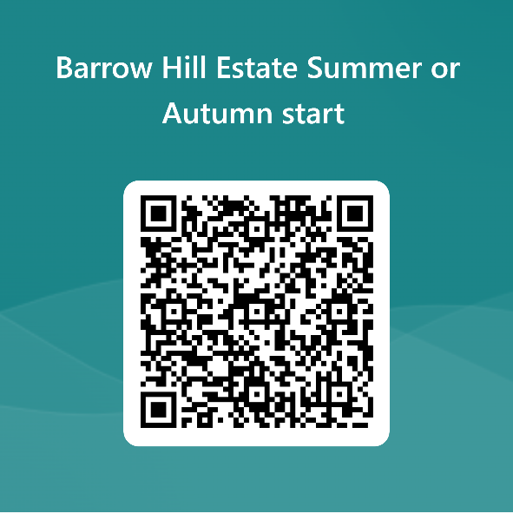

Please can you do this before 5pm on Wednesday 22 May.

I will send another letter out confirming the outcome however if you have any other questions relating to these works, please do not hesitate to contact me.

Yours sincerely

Diane Volpi
Resident Advocate

