**HOSPITALITY & LEISURE SECTOR DATA**

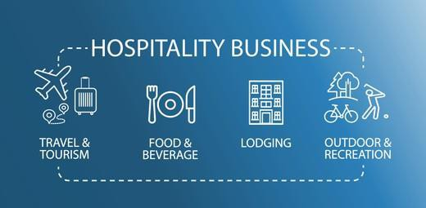

**INDEX**

**Page**

1. Introduction 3

2. Impact of Covid and Brexit 4 – 6

3. Recruitment Challenges 7 – 8

4. Hospitality businesses struggling to fill

vacancies

9 – 10

5. Skills and workplace learning in the hospitality

industry

12 - 14

6. List of Recommendations 14

7. Government & Local Authority Covid-19 Support

14 -16

8. References 16

**1. Introduction:**

The Hospitality sector creates £130bn in economic activity and generates £39bn of tax for the Exchequer, funding vital services. Hospitality represents 10% of UK employment, 6% of businesses and 5% of GDP. Hospitality is the 3rd largest private sector employer in the UK; double the size of financial services and bigger than automotive, pharmaceuticals and aerospace combined. Hospitality is the third largest business sector in the UK, based on employed workers, accounting for 1 in 10 jobs, and **employing over 3 million people**.

There are over 3000 hospitality businesses within Westminster area, including Food and Accommodation services, (UK Business Counts, April 2021) employing over 80,000 people, BRES 2020. and 4,415 leisure businesses, including the Arts, entertainment, recreation & other industry services, (UK Business Counts, April 2021), employing 41,000 people. Westminster is the hub for world renowned names, innovative start-ups and a wider supply chain. Currently, there are 27 Michelin star restaurants within the area of Westminster.

The hospitality sector has had a historically high staff turnover rate and in more recent times the changing landscape around attracting and retaining talent is getting more challenging. For the previous 15 months the hospitality sector has been brought to a virtual standstill by the pandemic, (which included a series of economically brutal lockdowns), requiring the hospitality sector to close, displacing hundreds of thousands of hospitality workers.

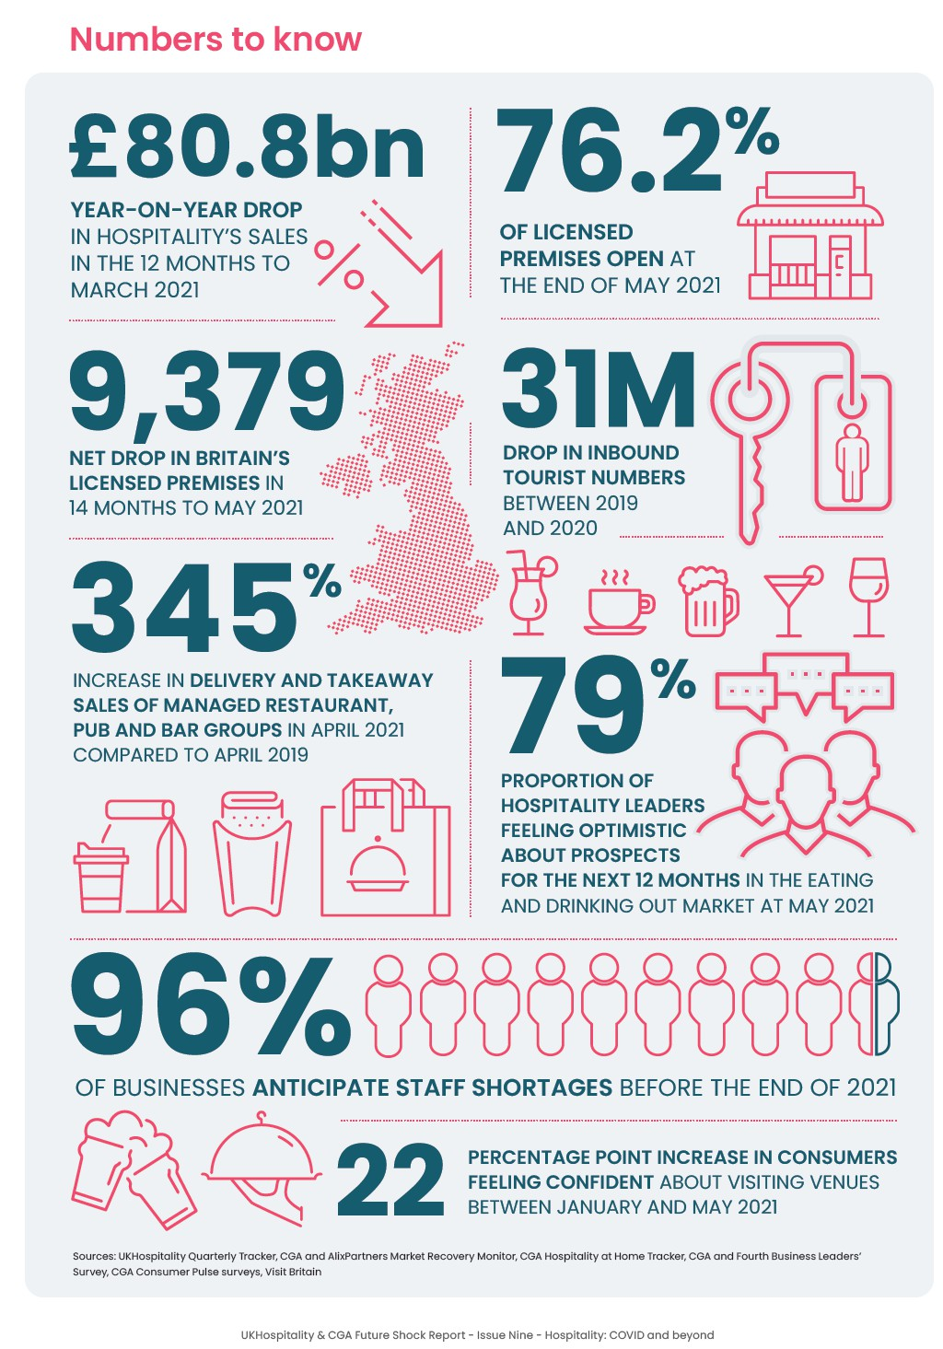

**2. Impact of Covid and Brexit:**

Hospitality (Accommodation and Food activities) and Leisure (business that provides opportunities, experiences, and facilities, in particular for culture, recreation, entertainment, celebratory events, days and nights out, betting and gaming) has been one of the sectors most affected by lockdowns and government restrictions throughout the coronavirus (COVID-19) pandemic. The sector may have also been affected by Brexit, but as the end of the transition period coincided with the start of the latest lockdown, it is hard to separate the effects of the two.

Restrictions on trading have significantly impacted hospitality business turnover. Economic output in the hospitality sector was down 90% in April 2020 compared to February 2020. Output recovered over the summer of 2020, boosted by easing coronavirus restrictions and the Eat Out to Help Out scheme in August, but was still below pre-pandemic levels. Output declined again from September as Covid-19 cases rose and restrictions were imposed.

Ongoing fixed costs and accumulating debt alongside persistent lower revenues and low cash reserves are a major concern for the sector. As of early March (22 Feb–7 March 2021) the ONS reported that 43% hospitality businesses were trading, compared to 74% across all industries. 55% of hospitality businesses had temporarily paused trading, compared to 24% across all industries.

Almost 1 in 5 hospitality businesses (19%) had “low confidence” that their business would survive the next 3 months. From January-March 2020 to July-September 2020, the number of workers in the sector fell by 6% (147,000). However, the pandemic has not yet resulted in the expected increase in unemployment, partly due to the Coronavirus Job Retention Scheme (CJRS). The number of jobs on furlough under the CJRS in the food & accommodation sector peaked on 10 April 2020, at 1.6 million jobs.

From April to October 2020, the number of furloughed jobs fell significantly. However, there have been increases due to two separate national lockdowns since October. On 31 January,

56% of eligible jobs in food & accommodation were furloughed under the CJRS, compared to 16% across all industries.

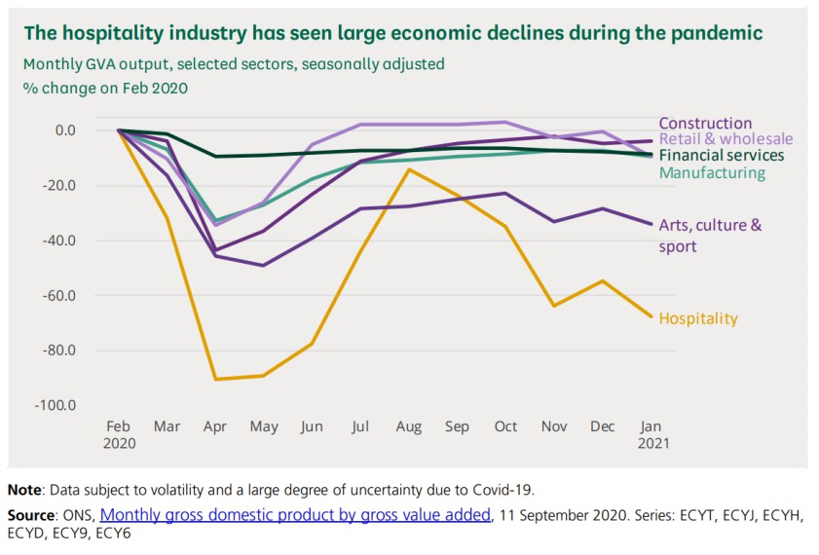

Hospitality and Leisure sector has been hit hard by the coronavirus (COVID-19) pandemic and the impact has been uneven; bars and clubs have fared the worst, but campsites had a relatively better year than the rest of the sector.

Consumer spending on hospitality started to increase in May 2021 but remains at less than

70% of pre-pandemic levels; a similar picture is seen in turnover - in May this remained one- quarter lower than 2019 levels.

Spending by businesses in the hospitality sector has seen smaller increases compared with consumer spending in May 2021; payments to suppliers from food and drink businesses have remained around half of pre-pandemic levels.

Confidence of business survival in the hospitality sector started to increase in May 2021 but remains below the all-sector level.

Job vacancies in the hospitality sector have seen large increases and are higher than pre- pandemic levels; however, in June 2021, the number of employees within the sector remained 11% below February 2020 levels.

Data from HM Revenue and Customs (HMRC) show that in April 2020, just under 1,650,000 employees in the sector were on furlough as businesses paused trading, falling to just under

590,000 employees furloughed at the end of May 2021 (Figure 1). This represents 25% of all furloughed employees.

**Figure 1: Furlough numbers in the hospitality sector continue to fall, as demand for labour increases**

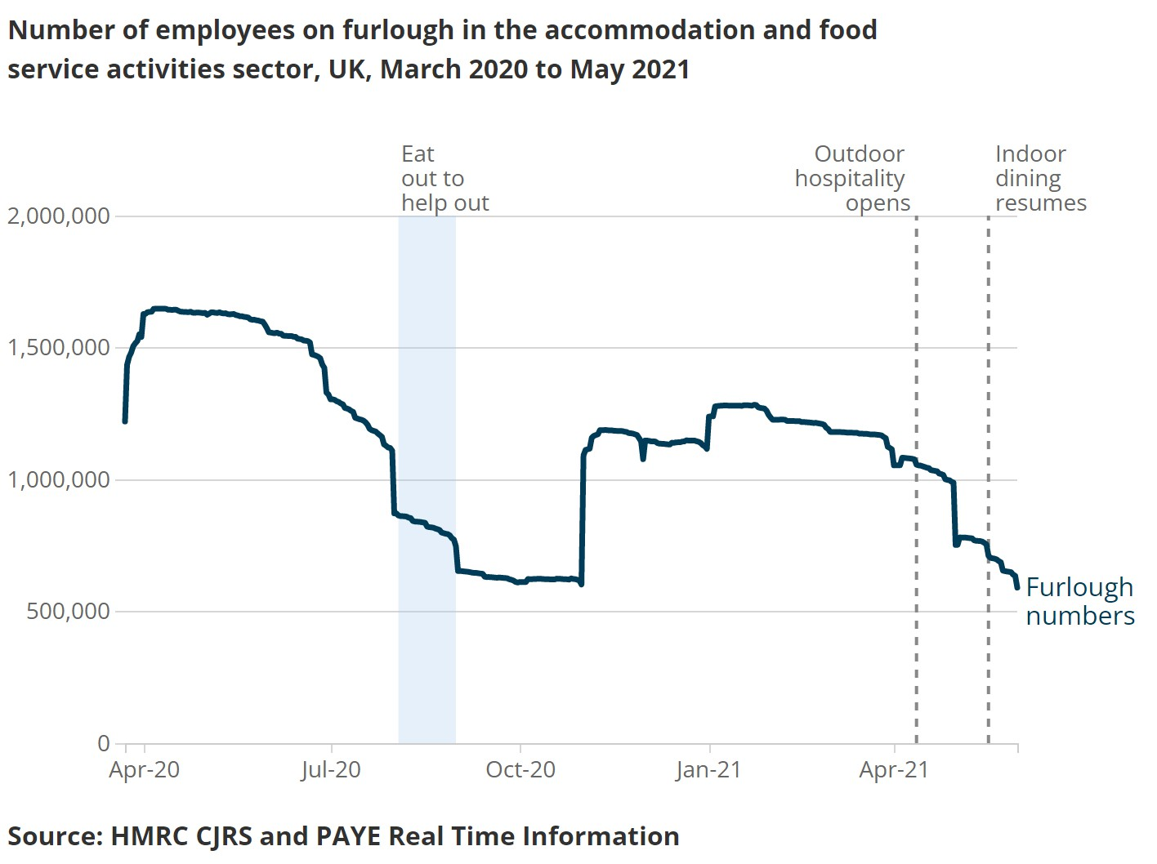

As we moved through the pandemic, the hospitality sector adapted to the changing restrictions, with the proportion of businesses temporarily closed falling from 81% in the spring 2020 lockdown to 54% in the early 2021 lockdown.

Business turnover (Figure 2) also reflected this change, showing higher revenue in early

2021 than in spring 2020. In May 2020, turnover was just over £1.2 billion, compared with

£3.4 billion in March 2021. This rose further to £6.9 billion by May 2021 after restrictions were partially eased, the highest figure since August 2020. Although this is still around 25% lower than its 2019 level.

**Figure 2: Hospitality sub-sectors saw large falls in turnover because of restrictions and are yet to recover**

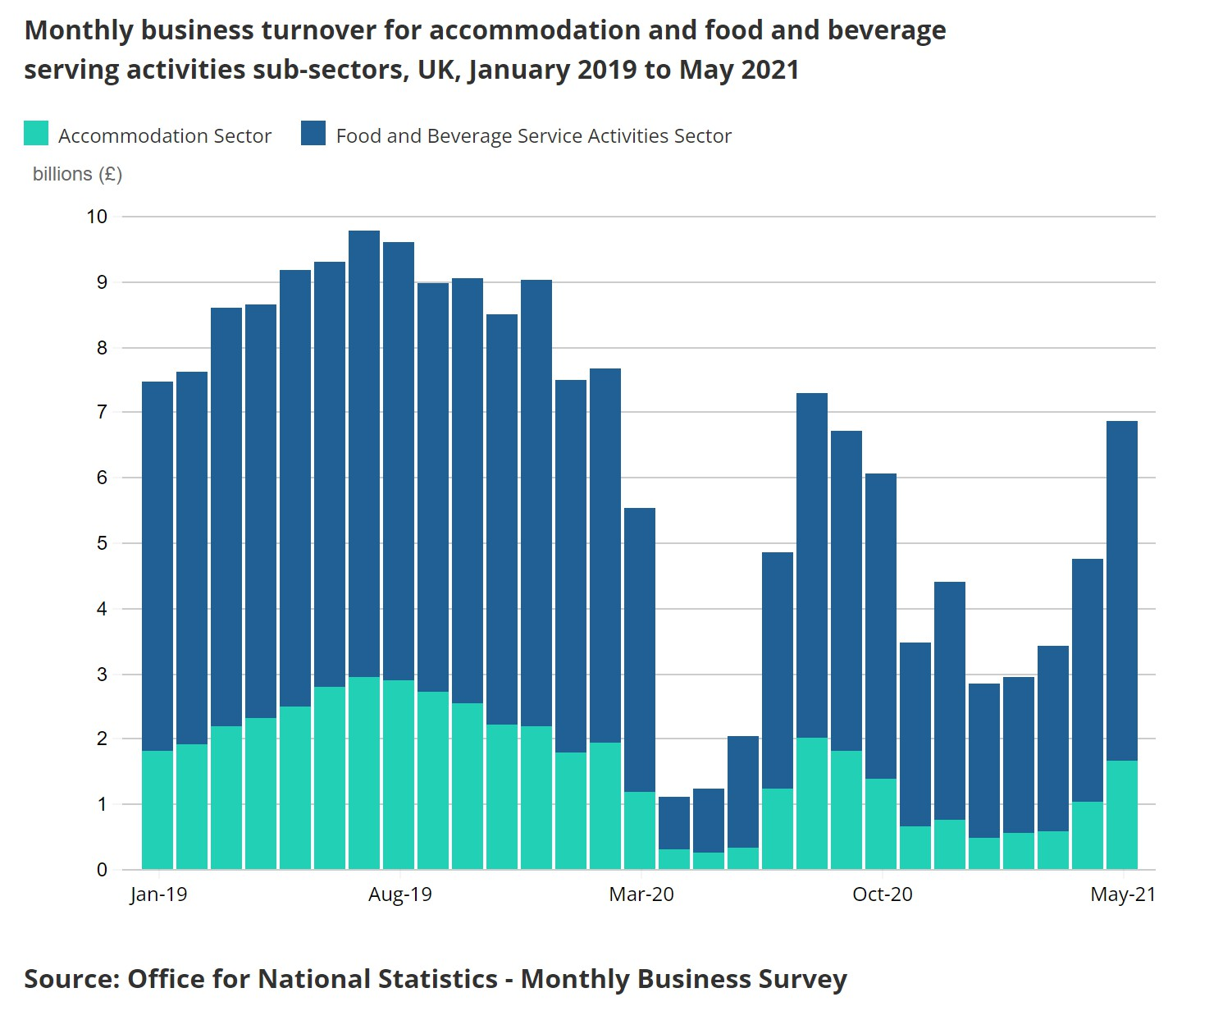

**3. Hospitality Recruitment Challenges**

The uncertainty and stop start nature of the pandemic, variants, lockdowns, and reopening are prolonging the hospitality talent crisis.

• 92% of firms in the hotels and catering sector reported difficulties, while 75% of service sector firms said likewise, both the highest response rates on record for the dataset going back to 1997

• 75% of service sector firms who attempted to recruit faced difficulties, the highest proportion since the introduction of the dataset in 1997 and up from 69% in Q2.

• This was driven by the hospitality and catering sector, among whom 92% of those who attempted to recruit reported difficulties, a significant rise from 76% in Q2.

Following are major recruitment challenges faced by the Hospitality Sector:

*1. Lack of confidence in the sector*

‘Waiting staff and chefs are in particular demand as Covid-19 restrictions continue to ease’, according to UKHospitality, reporting on the **BBC**. The industry body go on to suggest that **a lack of ongoing confidence in the hospitality sector is driving these shortages**, and is preventing venues in some areas from opening fully or even at all.

The pandemic has left the hospitality sector with chronically low levels of job security, and hospitality staff are choosing other more reliable sectors. “People are still nervous about committing to hospitality, fearful that the government may still impose restrictions. The single biggest driver is uncertainty.” Kate Nicholls, chief executive officer of the lobby group UK Hospitality, speaking on **Bloomberg**.

*2. Chef Shortages*

Estimates suggest that the UK will need another 11,000 chefs by 2022. 6 key reasons for the chronic shortage according to the People1st report, ‘**The Chef Shortage: A Solvable Crisis**’ are:

**1.** Increased demand for chefs

**2.** The changing nature of chef roles

**3.** A shrinking labour pool

**4.** Too few chef apprentices in the sector

**5.** Too few full-time chef students entering and staying in the sector

**6.** The changing nature of chef turnover and chefs leaving the profession

*4. Lack of career progression*

A **recent report** by the online training provider, High Speed Training, reported on food service equipment journal revealed, that a third of people feel that roles in hospitality offer little progression and are not considered ‘careers for life’, with further negative perceptions around low salaries and workplace stress’.

Brexit may exacerbate hospitality skills shortage, especially with chefs. According to data from the Office of National Statistics Since March 2020, almost 300,000 hospitality people are thought to have left their jobs and returned to their home countries. There is huge uncertainty around when and if they will return. If and when these displaced EU workers look to return to the UK, hospitality recruiters will face increased regulations around employing them, relating to visa requirements, right to work status and becoming an approved employee sponsor.

Also, research from Indeed.com has revealed that,**‘the number of EU citizens searching for work in Britain has reduced by 36% in May from average levels in 2019, with low paid jobs in hospitality recording the biggest declines at 41%’.** The article highlighted that while high paying UK jobs were

managing to attract enough applicants from non-EU countries to offset falling EU interest, low paying hospitality jobs were not.

*4. New Points Based Immigration System*

The government’s new points-based immigration is expected to significantly impact the hospitality sector and it’s recruitment activities, according to **Catch22 Reponse to UK Immigration Plans**. Key trends here 24% of the UK hospitality sector workforce come from the EU, 50% of UK chefs are born abroad, (74% in London).

The minimum salary threshold to apply for the Points-based immigration system is set to be

£25,600, meaning the hospitality sector may no longer be able to recruit much of their lower skilled talent from Europe and may be reliant on the domestic market.

*5. Most furloughed hospitality workers don’t want to come back.*

Another unknown, as highlighted in this **Caterer.com** article, ‘Covid, Brexit and the future of the hospitality talent pool’, relates to how many of the furloughed hospitality workforce will decide to remain in the sector after the schemes end. The hospitality sector cannot rely on furloughed staff returning to the sector as research outlined here on **hrdirector.com** reveals that, ‘64% of furloughed hospitality workers are considering, or have already decided on, a career change since being placed on the UK government furlough scheme 17% are actively using their time to reskill in order to change careers’. “Some of our top, top chefs are now in construction, in scaffolding, earning more money in that

sector than working unsociable hours in a hot sweaty kitchen,” says. Rodney Burt, director

at Fire Hospitality, speaking in the **Telegraph**.

**4. Hospitality businesses are most likely to be struggling to fill vacancies**

With the number of UK job vacancies at a record high, some industries are reporting difficulties in recruiting new staff. A lack of EU applicants is contributing to recruitment challenges, particularly in transport and storage.

Hospitality businesses are more than twice as likely as other industries to be experiencing challenges in filling vacancies compared with normal expectations for this time of year. Between 23 August and 5 September 2021, 30% of hospitality businesses said that vacancies were more difficult to fill than normal. This compares with 13% across all industries (up from

9% in early August).

Vacancy challenges are more common for larger businesses. Excluding those with fewer than 10 employees, 41% of businesses across all industries were struggling to fill vacancies in late August, up from 32% earlier in the month.

These difficulties coincide with a very busy time for recruitment, according to the

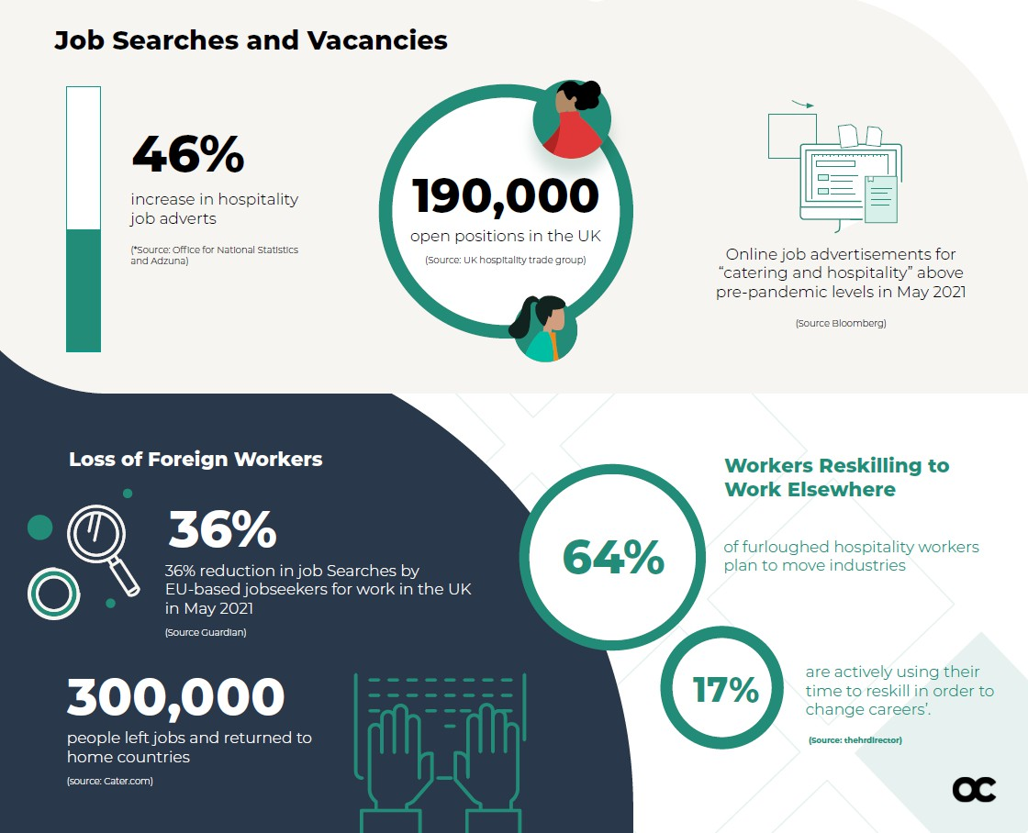

latest labour market data, with hospitality among several industries posting record numbers of vacancies in June to August 2021.

**4 in 10 hospitality businesses are finding vacancies difficult to fill**

The number of job vacancies is rising quickly as coronavirus (COVID-19) restrictions ease

It was always anticipated that after Brexit there would be a shortage of people to work in many businesses in the UK, but with the pandemic, travel restrictions and increase in demand, the hospitality sector is really struggling with staffing.

Typically jobs in hotels, restaurants, cafes, and pubs are low paid, often seasonal or without guaranteed hours. For years they have relied on workers from the EU coming to the UK to work, and therefore many were already preparing for the reduction in staff, but with the pandemic has come added pressure created by a lack of available staff

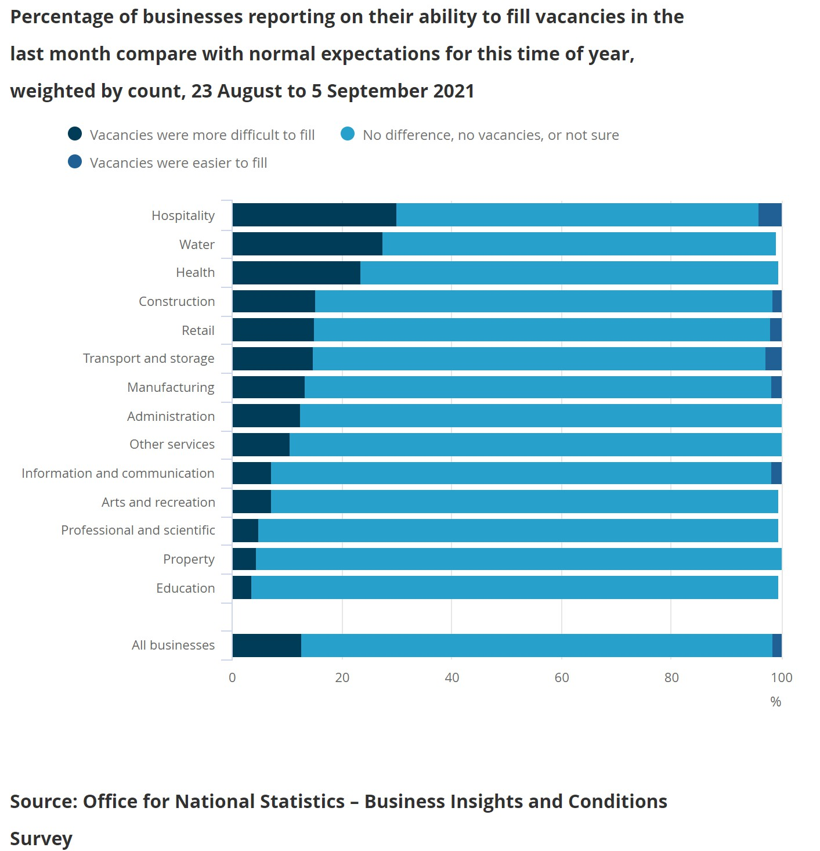

• There were 1,034,000 job vacancies in the UK in June to August 2021, an increase of

35.2% (269,300) on the previous quarter and the highest since the series began in

2001.

• The hospitality and transport and storage industries were among those with a record number of vacancies in June to August, with job openings up by 59.1% and 32.5% respectively compared with pre-pandemic (January to March 2020).

• While vacancies are at record levels, the total number of employees on UK payrolls is around the same as it was in February 2020.

• Among industries, pay-rolled employment was generally rising in August 2021, but remained below pre-pandemic levels by as much as 6.0% in hospitality and 10.2% in arts and recreation.

• New Data from UK Hospitality suggests a current vacancy rate of 9% implying a shortage of 188,000 workers.

Vacancies are above pre-pandemic levels, but the number of pay-rolled employees is yet to recover in some industries

**Vacancies by selected industry, UK, December 2019 to February 2020 to June to August 2021, Index Jan-Mar 2020 = 100; Payrolled employment by selected industry, UK, February 2020 to August 2021, Index Feb 2020 = 100**

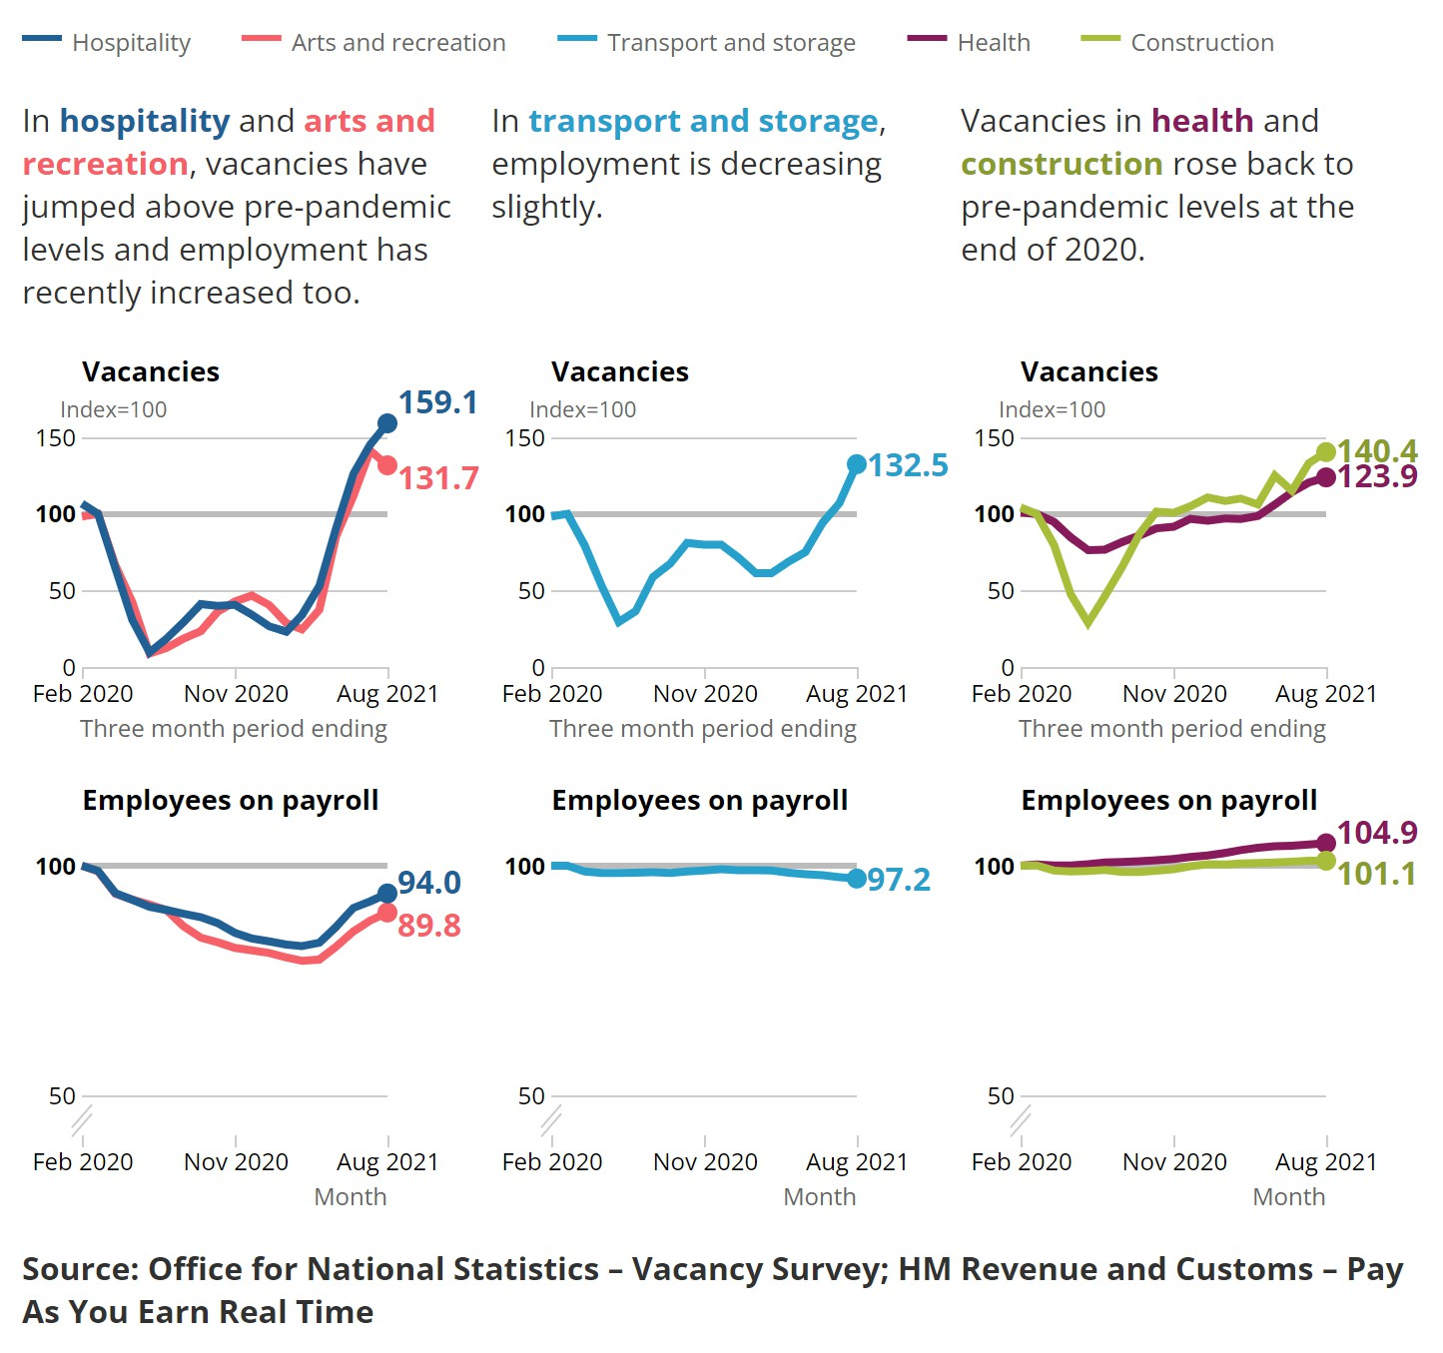

**5. Skills and workplace learning in the hospitality industry**

A key priority for the hospitality industry is to work with government and businesses to address the skills and labour gaps in the sector, to ensure that the industry can continue to thrive.

Hospitality offers its employees a meritocratic career pathway which provides development and progression without prejudice and can create a fulfilling career for life. A job and a career in hospitality can be critical to personal development, with businesses investing in each employee through training.

Employers in the hospitality sector pride themselves on providing opportunities and training for anyone wanting to enter the sector. The Commission heard how the industry already has several excellent training schemes in place and how apprenticeships, for any ages, are

crucial to businesses across the country.

The following recommendations were developed by the UK Hospitality Commissioni to set out ways to ensure the industry fully invests in upskilling its employees and promotes the talent which is already within the hospitality sector.

**Recommendation 1: Industry to attract and retain employees via lifelong learning and on- the-job training**

The Commission repeatedly heard that the hospitality industry must champion its employees, investing in lifelong learning and celebrating the sector’s existing good practice when it comes to training.

With the sector’s growth predicted to continue in the coming years, and with a target of up to 200,000 new apprenticeships over the next five years, witnesses emphasised how government and industry must together promote long-term career pathways in hospitality and assess the social, cultural, and economic factors which impact this.

Michael Chambers and Oliver Hawkins (apprentices at Park Plaza Hotels) and Henry Layton (apprentice at The Ritz), all told the Commission that they had cultivated invaluable skills during their ‘on the job’ training in the industry, allowing them to actually put theory into practice.

As such the Commission recommends that the industry continues to focus on lifelong learning and promotes the benefits of on-the-job training.

**Recommendation 2: Government should promote and value the benefits and**

**transferability of ‘soft skills’**

So-called ‘soft skills’ such as communication, teamwork and dedication, were identified as a critical component of the skills make-up of hospitality staff, though it was felt by a broad range of stakeholders that this term did not adequately represent this skillset.

‘Soft skills’ are persistently overlooked by the Government in contrast to the ‘hard skills’

emphasised in the Government’s Industrial Strategy.

The Commission heard how official definitions are not helpful to the sector as they define many hospitality occupations as ‘low skilled’ despite substantial levels of skill being needed to fulfil the role. The misclassification of these skills is damaging for both staff wellbeing and for wider business recruitment, and so it should be avoided both by government and the industry itself.

In addition, Nigel Huddleston MP pointed out that high skilled jobs are often too easily conflated with high wage jobs. The Commission heard that soft skills are fundamental to working in the industry and carry huge value. These skills are essential for a prosperous economy and can ensure that employers find the right staff members, and that employees secure the jobs that are available. Soft skills are not only beneficial to the hospitality industry but are transferable across industries, and countries, where the service industry is regarded more positively. These skills can also drastically improve social mobility.

In response, the Commission notes that the industry must promote the talent nurtured within the hospitality sector and ensure that a career in hospitality is truly recognised for the high skilled occupation that it is, as is already the case in continental Europe.

**Recommendation 3: Conduct an urgent review of the effectiveness of the Apprenticeship**

**Levy, increase the transfer fund cap to 50% and tackle the costs of off-the-job training**

Apprenticeships are a key pathway into the hospitality industry. In 2016-2017, 25,000 people joined the industry via this route.

The Apprenticeship Levy, which came into force in April 2017, in its first year released only

£108 million of the money available through the collection of the Levy4. Broadly welcomed by the industry as an opportunity to increase the number of apprenticeships nationwide, the Commission heard how the Levy disproportionately impacts SMEs which make up more than 90% of the hospitality industry.

Under the Levy, small businesses are unable to afford funding for apprentices. The Yummy Pub Co. highlighted that prior to the introduction of the Levy, the company had 12 apprentices but now has none as a result of increased costs. Of note, this was not due to the lack of want but as a result of already thin margins being further eroded.

Witnesses called for the Apprenticeship Levy transfer fund cap to be expanded from 10% to

50% to help support SMEs. This could enable larger companies, who can’t or don’t want to

use their levy, to gift it to an employer or relevant SME who can use it. For example, a large pub chain could gift it to their tenants to pay for any relevant apprenticeship training for the tenant’s staff.

Another issue is the costs associated with apprenticeships, beyond the Levy payment. Witnessed suggested that the required 20% off-the-job training and development could be split between the employer’s time and the apprentice’s own time. This would reduce the cost implications for employers whilst allowing apprentices to take further responsibility for their learning.

**6. Skills and Workforce Learning – further recommendations**

Based on all the evidence received the Commission developed 6 recommendations to support the retention, growth and perception of the hospitality workforce.

**Recruitment and retention**

1. A cross-industry, national campaign to eliminate negative perceptions of hospitality careers.

2. DWP/industry collaboration to showcase careers information and the ‘best face of the

Industry.’

3. Adapt schools’ outreach to enable direct dialogue between hospitality businesses and students.

**Diversity**

4. Immigration policy must be evidenced-based, tailored to hospitality workforce needs

5. Industry to achieve greater workforce diversity best practice through employment contract flexibility.

6. Government support for workforce upskilling to encourage older and ‘harder to place’

workers into the sector, or back into employment.

**7. Government and Local Authority Covid-19 Support**

While forced closures and restrictions have limited customer demand and business revenues, hospitality businesses still face fixed costs such as certain property and staff costs. The hospitality and leisure industries has benefited from business support schemes available to all industries, such as the Coronavirus Job Retention scheme, business loans and grants. In addition, the UK Government has provided some support schemes specifically targeted to the hospitality industry, such as the Eat Out to Help Out scheme and a temporary cut to VAT.

**Coronavirus Job Retention Scheme (CJRS)**

Up to 31 October 2020, claims worth £6.89 billion had been made by businesses in the food service and accommodation sector under the CJRS, 16% of the total value of all claims. Only the wholesale and retail sector had a higher amount claimed (18% of the total value). 15

From 1 November 2020 to 31 January 2021, the total value of claims made in the food service and accommodation sector was £2.52 billion. This was the highest amount claimed by all sectors and was 25% of the value of all claims made. This brings the total claimed by the sector under the CJRS to £9.41 billion (provisional).

**Business loans**

There are two main loan schemes that represent the majority of loans: the Coronavirus Business Interruption Loan Scheme (CBLIS) and the Bounce Back Loan Schemes (BBLS). As of 11 January 2021, 117,864 loans (CBILS and BBLS) worth £5.51 billion in total had been offered to hospitality businesses, representing 9% of the total loan value across all sectors. This corresponds to 53% of hospitality businesses being offered a loan. In comparison, approximately 26% of UK businesses overall had been offered a loan.

**Eat Out to Help Out Scheme**

The Eat Out to Help Out scheme (EOHO) provided 50% off the cost of food and non-alcoholic drinks eaten-in at participating restaurants on Monday to Wednesdays in August.

Overall, £849 million was claimed under the Scheme across 78,116 outlets.

**Temporary VAT cut**

VAT for hospitality, accommodation and visitor attractions has been temporarily reduced to 5% (from 20%) from 15 July 2020 to 330 September 2021. A 12.5% rate will then apply for the six months until 31 March 2022, when it reverts back to 20%. The reduced rate applies to food and non-alcoholic drinks served in hospitality venues in addition to accommodation services and admission to certain visitor attractions.

**Expanded retail relief**

Retail, hospitality and leisure businesses in England were in receipt of 100% rates relief on their business rates bills from the period of April 2020 – June 2021. A 66% relief is now in force for all eligible sectors until 31 March 2022. In total Westminster City Council have allocated over £1billion in rates relief for these eligible sectors.

**Business grants**Businesses in the retail, leisure and hospitality sectors in England that are eligible for full business rate relief, and which occupy properties with a rateable value of £51,000 or under, were entitled to a grant of £25,000 or £10,000 in respect of each qualifying property that they occupy in 2020-21. This grant scheme ran from March-August 2020. A series of further grant schemes have since been administered by Westminster City Council following the receipt of various funding pots from central government to support the hardest-hit sectors, of which the Hospitality and Leisure sectors were included. The average ratepaying businesses within Westminster under these sectors has received approximately £50,000 in grants from Westminster City Council. To date Westminster City Council have administered over £311M in grants to over 8000 eligible businesses in the borough. The Additional Restrictions Grants are also included within this figure and was administered as a discretionary scheme to mirror the support provided for ratepaying businesses within these sectors, for non-ratepayer businesses.

**Movement Strategy & Alfresco Dining Scheme**

Our Movement Strategy allowed for a safe re-opening of the borough. The Alfresco scheme delivered pavement licenses for in excess of 560 premises, creating 17,000 ‘covers’. 60 streets were transformed with temporary road closures and pavement widening to allow for outdoor restaurant seating in the street. This provided a lifeline to the local economy, bringing much needed confidence and footfall back to Westminster. It came to an end on 30 September 2021 as businesses now operate to capacity indoors. Businesses can still apply for a licence to allow outdoor dining on pavements, providing there is sufficient access for pedestrians. Moving forward there are 11 areas where permanent schemes are being developed. Additionally, the Council’s Statement of Licensing Policy has been revised to be more supportive of new applications from retail premises to be licensed to sell alcohol, provide entertainment or late-night refreshment as an ancillary function to the main premises use.

**Business Resilience Support**

The City Council delivered a wide range of support to businesses to build their resilienceincluding an online local ‘Open for Business’ directory and map; signage and other assets to help businesses re-open; COVID marshals to help businesses re-open safely; free digital skills training delivered to over 300 businesses particularly on the high-street, to continue to trade and deliver their goods to their customers; business preparedness, continuity & resilience support to ensure businesses were able to continue trading in a COVID-secure manner; a resilience themed Pop-Up Business School and an ‘Adapt-Survive-Thrive: Resilience for future growth’ pilot. With the end of Furlough and end to the 100% rates free period for business rates, we have recently convened a professional panel of expert organisations willing to provide pro-bono support to businesses in crisis. This will focus on businesses restructuring, raising finance, pivoting into more profitable areas, identifying salvageable aspects of the business, staff redeployment. Where it is ultimately unavoidable, the panel will assist managing redundancy processes and business closure processes professionally and responsibly and ensure a proactive and timely ‘Response to Redundancy’ service to be delivered by WES, WAES and DWP.

**Initiatives to increase footfall in the City**

To encourage visitors back into Westminster we delivered the Sightsee Crowd Free campaign offering visitors the opportunity to see the West End like never before. The campaign resulted in a 38% increase in visitors to the West End. The first ‘Inside Out’ festival was launched in August this year and ran to end of October. Highlights included: Underbelly Festival in Cavendish Square (Total footfall to the event site was 70,000 with over 15,000 tickets sold for shows); National Gallery’s Nations Favourites (over 9,000 people participated; Skate the Strand (over 250 free skateboarding sessions provided); and West End LIVE – (57,000 people attended). To attract footfall back into central London the council has launched its first destination campaign, Westminster Reveals, to highlight the diverse and exciting array of entertainment, hospitality, arts, and culture unique to the city. The dedicated Westminster Reveals website promotes events taking place as far ahead as June 2022. We have engaged PR agency, Sister, to market the local offer and attract more press and publicity coverage.

**8. References**

1. [UKHospitality Press Centre](https://www.ukhospitality.org.uk/page/PressCentre)

2. [Coronavirus and its impact on uk hospitality](https://www.ons.gov.uk/businessindustryandtrade/business/activitysizeandlocation/articles/coronavirusanditsimpactonukhospitality/january2020tojune2021)

3. [UKHospitality Future Shock Report](https://www.ukhospitality.org.uk/page/FutureShock-IssueNine)

4. [Coronavirus how people and businesses have adapted to lockdowns Report](https://www.ons.gov.uk/economy/economicoutputandproductivity/output/articles/coronavirushowpeopleandbusinesseshaveadaptedtolockdowns/2021-03-19)

5. [Hospitality businesses struggling to fill vacancies](https://www.ons.gov.uk/employmentandlabourmarket/peopleinwork/employmentandemployeetypes/articles/hospitalitybusinessesaremostlikelytobestrugglingtofillvacancies/2021-09-16)

6. [Hospitality Shortages Report](https://www.bighospitality.co.uk/Article/2021/06/03/Hospitality-staff-shortages-recruitment-Sadiq-Khan-UKHospitality-BBPA-Department-for-Work-Pensions-Jobcentre-Plus)

7. [Recruitment-and-retention](https://realemploymentlawadvice.co.uk/2021/06/03/recruitment-and-retention-the-number-one-problem-for-the-hospitality-industry/)

8. [Occupo Hospitality Data](https://f.hubspotusercontent00.net/hubfs/4131452/Occupop%20Hospitality%20Trend%20Report%2020212.pdf?utm_campaign=Guide%20Red%20Carpet&utm_medium=email&_hsmi=155177132&_hsenc=p2ANqtz-_4GaCLHCKtcd-cNo8RxHOL0_8LNQVfSRaRgsopp9YpvO_6fR6yInSJ8aIZgCryHbcQcZsGwPb4CbZvUbdYI4uoCR1P64V7oL4PPyDRF8ZTn5lck7c&utm_content=155177132&utm_source=hs_automation)

9. [Research Briefings UK Parliament](https://researchbriefings.files.parliament.uk/documents/CBP-9111/CBP-9111.pdf)

10. [Commons Library Briefing, 22 March 2021](https://commonslibrary.parliament.uk/research-briefings/cbp-9111/)

11. [UK Hospitality Workforce Commission 2030 report](https://www.youthemployment.org.uk/dev/wp-content/uploads/2018/09/UK-Hospitality-Workforce-Commission-2030.pdf)

i UK Hospitality Workforce Commission 2030 (UK Hospitality)