Westminster Neighbourhood CIL Application Form



Introduction

This is the form to apply for funding from the Westminster City Council’s Neighbourhood Community Infrastructure Levy (NCIL).
CIL is a charge on development to help fund infrastructure which supports Westminster. It must be spent on new or existing public infrastructure needed to support development or growth, or on anything else that is concerned with addressing the demands that development or growth places on an area. Projects are selected with regard to national legislation, regulations and guidance, and the council’s local CIL policy (the CIL Spending Policy Statement) and guidance.
A portion of all CIL collected is apportioned to the one of 21 Neighbourhood Areas in which the contributing development is located. This is the Neighbourhood portion, or NCIL. Westminster City Council collects, retains and spends NCIL in consultation with the local community.
NCIL is allocated via an applications process, to allow the local community to propose projects that positively shape the area and improve the lives of community members. These applications are subject to consultation requirements with key local stakeholders to ensure that community views inform all decisions.
All applications must pass the Pre-Application Engagement Requirement, in which officers advise on a proposal’s eligibility for Neighbourhood CIL, and work with prospective applicant to develop the project and complete the application.
Following submission, applications are validated by officers to ensure all information needed to decide has been provided. Validated applications, along with supplementary information such as comments from local stakeholders, are reviewed by relevant officers from across the council, including officers who work on the type of infrastructure related to the proposal as well as Finance and Legal officers. Cabinet Members are briefed prior to officer recommendations made in a formal report. The decision is taken by a Cabinet Member, or in limited circumstances by the Full Cabinet of the council. Applicants are notified of the decision including all terms and conditions.
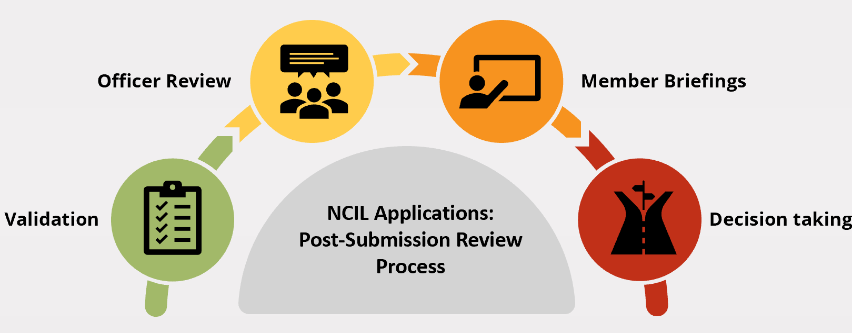

Instructions
1

This is the form to apply for funding from the Westminster City Council’s Neighbourhood Community Infrastructure Levy (NCIL).
What is the purpose of this form?
The purpose of this application is to collect information about the project and its eligibility and priority. All questions relate to the national legislation, regulations or guidance, and/or local policy. The information submitted will help the council decide the outcome of your application.

2
How do I complete this form?
The council accepts applications from any organisation or individual seeking NCIL funding for an infrastructure project which benefits Westminster.
Responses need not be limited to the space provided, but you should aim to provide information clearly and concisely. Please feel free to add pages or supplementary documents, as needed.
The form is currently available as a downloadable pdf. Please use a pdf form filler to input responses directly into the document. If you require the document in an alternative format, please email NCILprojects@westminster.gov.uk. Please email completed forms to NCILprojects@westminster.gov.uk.

The application form is an opportunity to make the case for your infrastructure project and to demonstrate how it meets the eligibility criteria and reflects the policy considerations and priorities set out in national CIL regulations and the local policy. Familiarise yourself with the policy (available here), and with the helpful guidance and advice on our website which explains those policies and how they should be applied to real-world projects).
What should I keep in mind prior to and whilst I complete the form?
3

All applicants must satisfactorily complete the Pre-Application Engagement Requirement prior to submission. This requirement is to help you produce the best application possible with the highest chance of success. Officers will advise you on whether your idea is appropriate for Neighbourhood CIL, and if it is, we will work with you to develop your idea and help you fill out your application. We will identify any issues you will need to resolve or additional information you will need to submit, as appropriate, in order to complete the pre-application engagement requirement.. Learn more about the Pre-Application Engagement Requirement here.

All applicants must satisfactorily complete the Pre-Application Engagement Requirement prior to submission. This process will determine the project’s eligibility with regard to relevant regulation and policy requirements, assist with project development, explaining (including by engaging with technical officers from across the council), and assisting with any other aspect of the process. Learn about the Pre-Application Engagement Requirement here.
If you have any questions, email the team at NCILprojects@westminster.gov.uk

Applicant Type
1
Applicant details
☐ Organisation
☐ Individual
Applicant Name
If the application is made by an organisation, then please provide the organisation’s name and the name of the organisation’s contact for this application; if an individual then please provide the individual’s name.

Address

Email Address

Telephone No.

Reputation of applicant
The council will not fund projects where doing so could bring the council into disrepute by means of being associated with the applicant. You must confirm that you are unaware of any reasons, including financial, legal, or reputational, that associating with the applicant could bring the council into disrepute.

You must tick the box below to confirm that your organisation or you as an individual have no financial, legal, or reputational issues that could bring the council into disrepute.
☐ Confirmation that applicant has no financial, legal, or reputational issues which could bring the council into disrepute by mean of being associated with the applicant as a funder
Please note that if you fail to disclose any adverse financial, legal, or reputational information which the Council subsequently becomes aware of it reserves the right to withhold any funds provisionally approved in respect of your project or seek repayment of any funds which have already been paid.

2
Project Details
Project Name

Project Location

Project Description
Provide an overview of the project. What is it? Why is it important? What are the aims and outcomes? Who will use the infrastructure/who will it benefit? Also provide any helpful context, for example if the project is part of a larger programme.
If you need additional space, you can submit a detailed Project Description as an attachment to your application.

Proposed start date

Proposed delivery date

Delivery partners
Project Details
If you are using a contractor, consultancy, etc., please provide their name and contact information including the name of your contact. If Westminster City Council will deliver the project on your behalf, please provide the name of the team and/or officer[s].

Management and maintenance
Please provide details for the management, maintenance, programming, administration, and any other relevant requirements over the expected lifespan of the infrastructure.

Studies and plans
Please list any technical feasibility studies, design work, or other work undertaken for the project. These documents should be included as attachments with the completed application form.
If this investigative/preparatory work is part of the NCIL funding request, ensure these are included in the list of elements to be funded by NCIL in Section 3.

Agreement of relevant stakeholders
If your project requires the agreement of stakeholders such as infrastructure providers, landowners, etc., please list their names and contact information including the name of your contact, and explain why you require their agreement. If you have not yet secured agreement, explain why not.

Project Details
Confirmation that project is not required by a planning condition or planning agreement or any other legal agreement
Projects or anything else which must be delivered as part of a planning condition or a developer contributions agreement such as a Section 106 agreement or Section 278 Highways Act 1980 agreement, or any other legal agreement requiring the applicant to deliver the project, are not eligible for NCIL. You must tick the box below to confirm that the project is not made ineligible by these criteria.
☐ Project is not required by planning condition or planning agreement or any other legal agreement
☐ Project is required by a planning condition or planning agreement or any other legal agreement

Planning permission
☐ Not required ☐ Required – application submitted but not yet decided
☐ Required and consented ☐ Required – application not yet submitted
If planning permission is required but you do not yet have consent (either because an application has been submitted by not yet decided or an application has not yet been submitted), please provide details.

Other regulatory consents required
In addition to any potential planning permission, please list and provide details of any other legal powers or regulatory consents required.

Financial details
3
Total NCIL funding request
State the amount of NCIL you are seeking. Generally, it will be the total cost of the project minus funding from other sources, such as other grants and gifts and your own contributions, if there are any.

Neighbourhood CIL Funding Pot[s]
State which Neighbourhood Area funding pot[s] you wish the funding to be provided from and explain why this is most appropriate pot[s] for your project (ie ‘project located in this neighbourhood area’, ‘users live in this neighbourhood area’, etc.). Further guidance here.

Total project cost
This should be the total cost of the project, not just the elements for which NCIL funding is sought

Other funding for this project
Provide the funder name, amount, and any other information of other funding sources for this project

Funder | Amount (£) | Notes

CIL funding needs details
Please provide a line-item budget of every element for which CIL funding is sought

Quotes
Summarise all quotes. Full quotes should be submitted with the application as attachments.

Value for money
Explain why the project is cost-effective and represents good value for money.

Future financial security (Only for requests to fund operations costs)
If you are requesting funding to operate the infrastructure for a time-limited period, please explain how the project will be funded after the time-limited period of NCIL funding.

NCIL and other WCC Funding
Detail any existing / previous NCIL funding and/or any other funding (including grants, capital project funding, etc.) awarded to you/your organisation by Westminster City Council, for any project or purpose within the last five years.

Required consultees
Consultation
4

Please tick the box next to each of the consultees listed below to confirm you have engaged with them. Also
provide names in the space provided.

Attach all relevant correspondence with each required consultee. At a minimum this must include the message you sent informing them of the project; all subsequently correspondence must be provided.

If you did not engage with a required consultee, please explain why. If you did engage but are unable to provide relevant correspondence, please explain why.

Further guidance is available here.

☐ Councillors (from the local ward)
Names:

☐ Confirm that relevant correspondence is attached

☐ Neighbourhood Forum[s]
Include the name of the Neighbourhood Forum[s] and the name of the person/people at the forum[s] with whom you engaged.
Name[s]:

☐ Confirm that relevant correspondence is attached

☐ Business Improvement District[s]
Name[s]:

☐ Confirm that relevant correspondence is attached

Pre-Application Engagement Requirement
Consultation
Please tick the box below to confirm that you have been informed that you have satisfactorily completed the Pre-Application Engagement Requirement for this application. Further guidance is available here.

☐ Pre-Application Engagement Requirement has been satisfactorily completed
Provide the name of the officer[s] with whom you engaged.

Other consultation/engagement
Please provide details of all consultation and engagement undertaken.

Local community support
Please demonstrate support for the project by the local community

Priorities, policies, and criteria
5
Council funding priorities
Does the project or an element of the project deliver any of the council’s five priorities for infrastructure funding?
☐ Enabling delivery of affordable housing
☐ Green transition
☐ Sustainable and active travel
☐ Community facilities
☐ Accessible and inclusive public spaces
If so, please explain how the project delivers the priority/priorities selected.

Supporting growth
How does the project address the impacts of development or otherwise support the growth of the City?

Plan-led
Is the project identified in, supported by, or otherwise aligned with the Neighbourhood Plan, if there is one, and Westminster City Council plans and strategies?

Carbon impact
Priorities, policies, and criteria
Has a carbon impact estimate been produced? If no, then why not? If yes, please note if the project is ‘zero carbon’. If the project is not zero carbon, what mitigation measures can be undertaken?

Equalities
Describe how the project aligns with the council’s commitment to equalities.

Anything else
Please provide any additional information to support your application.

6
Declaration
By submitting this application form you agree and confirm that all information you are providing is true to the best of your knowledge and understanding. Please note that any misinformation included in your application may lead to refusal of the application, cancellation of any allocated NCIL funds, and/or claw back of any provided NCIL funds.

Signature …………………………………………………………………………………

Date………………………………………………………………………………………..

