On line Guide to Licensing Registers

Get up to the minute information on licensing applications and changes to existing licences.

You can now search for and receive email updates and alerts on all valid licensing applications and current issued licences made to Westminster City Council.

It’s easy to register, simply go to http://idoxpa.westminster.gov.uk/online-applications/search.do?action=simple&searchType=LicencingApplication where you can sign up. You can select which applications to track, get notifications of new applications in locations you choose and make comments on line.
The On line Licensing register allows you to view pending applications or licences for all of our premises licensing regimes. You can make comments to pending applications, track specific applications and save your searches. You can also receive updates on your saved searches, for example if a new application is received or an existing application’s status changes.

In addition you will be able to view public documents such as licences and application forms, see the activities either permitted or applied for, conditions, any Licensing Sub-Committee dates, the status of the application and the proposed or current opening hours.

Registration

The search and registration/login page can be found here. http://idoxpa.westminster.gov.uk/online-applications/search.do?action=simple&searchType=LicencingApplication. You can carry out searches for both Planning and Licensing from this page but to save your searches and receive updates you will need to register / login.

Registering is simple; the only information required is your name, address, telephone number and e-mail address. You will be asked to create a password and once submitted you will receive an email confirmation. Once you click on the confirmation e-mail you are registered.

Searches

You can carry out searches for ‘applications for a licence’ or licences that have already been granted,
- Simple search

If you know it, you can search by entering the application reference number to view a specific application or licence, or by a street name such as ‘Oxford Street’ to view all outstanding ‘applications’ or ‘licences’

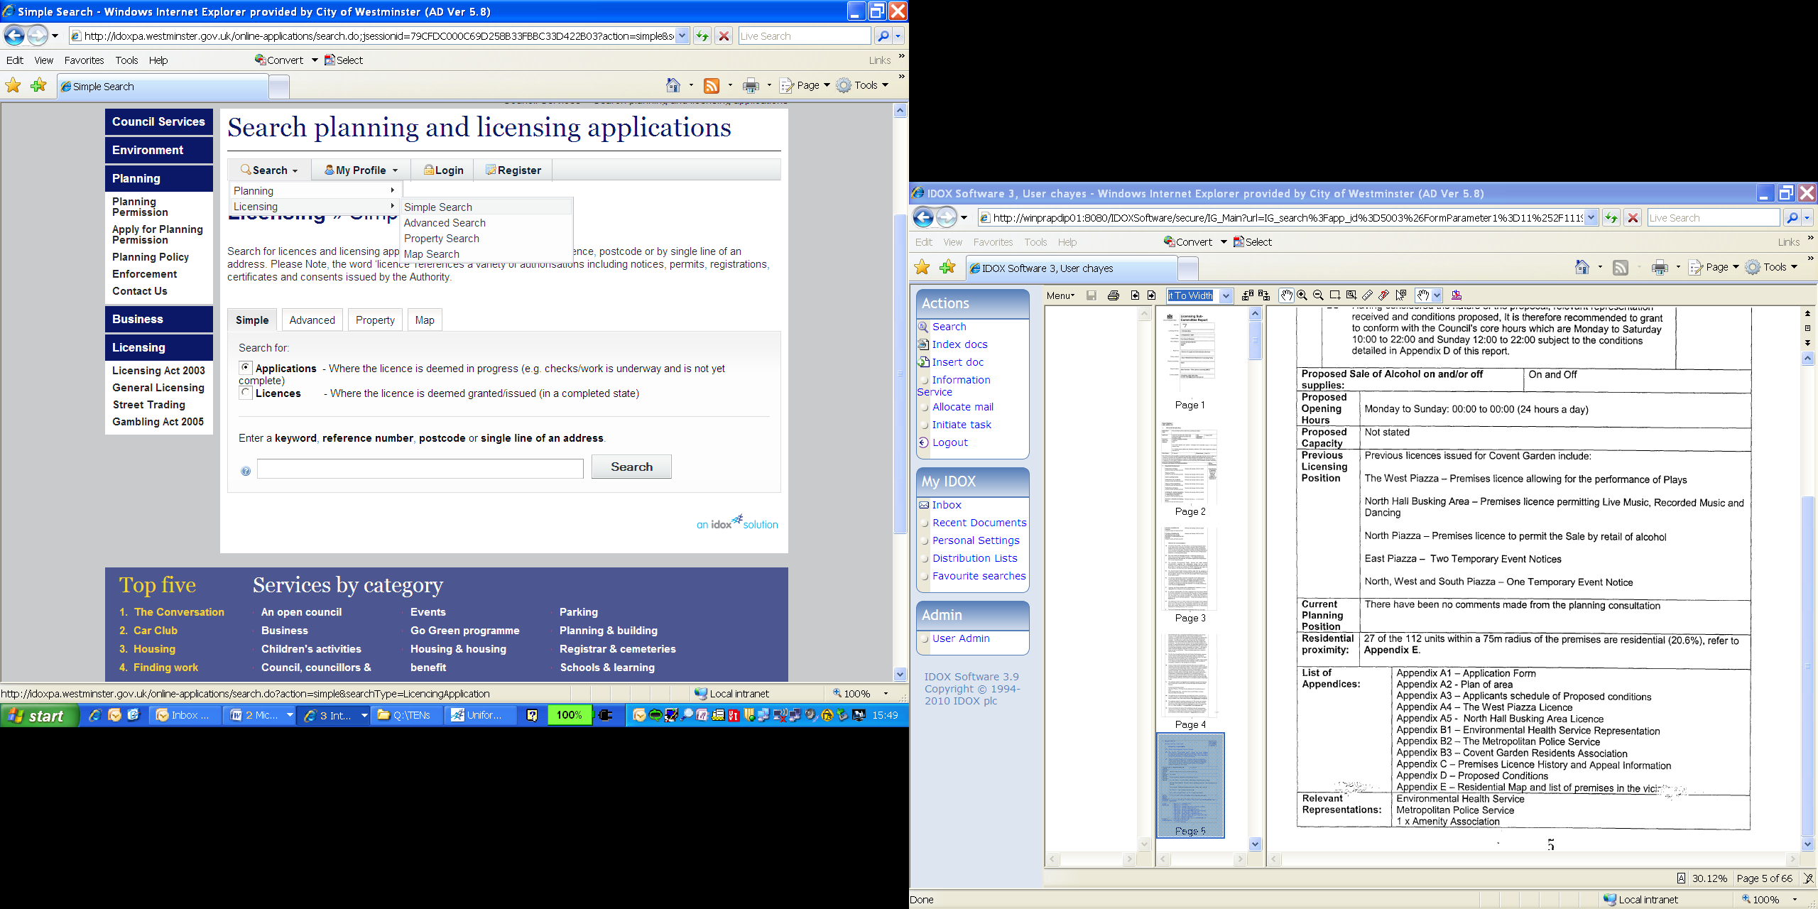
Choose licensing in the drop down box.

Choose either a search for applications or licences.

You can search by reference number, postcode or line of an address.

Cont.
- Advanced search

This search allows you to look for applications or licences by setting various parameters e such as ‘category’ – the drop down box allows you to specify what type of licence regime you would like to look for, for example if you opt for ‘premises’ your search will only look for matching results that relate to premises applications or licences applied for or issued under the Licensing Act 2003 and Gambling Act 2005. You can also search for premises names, addresses, decision, applicant name, activity types and times and received dates.

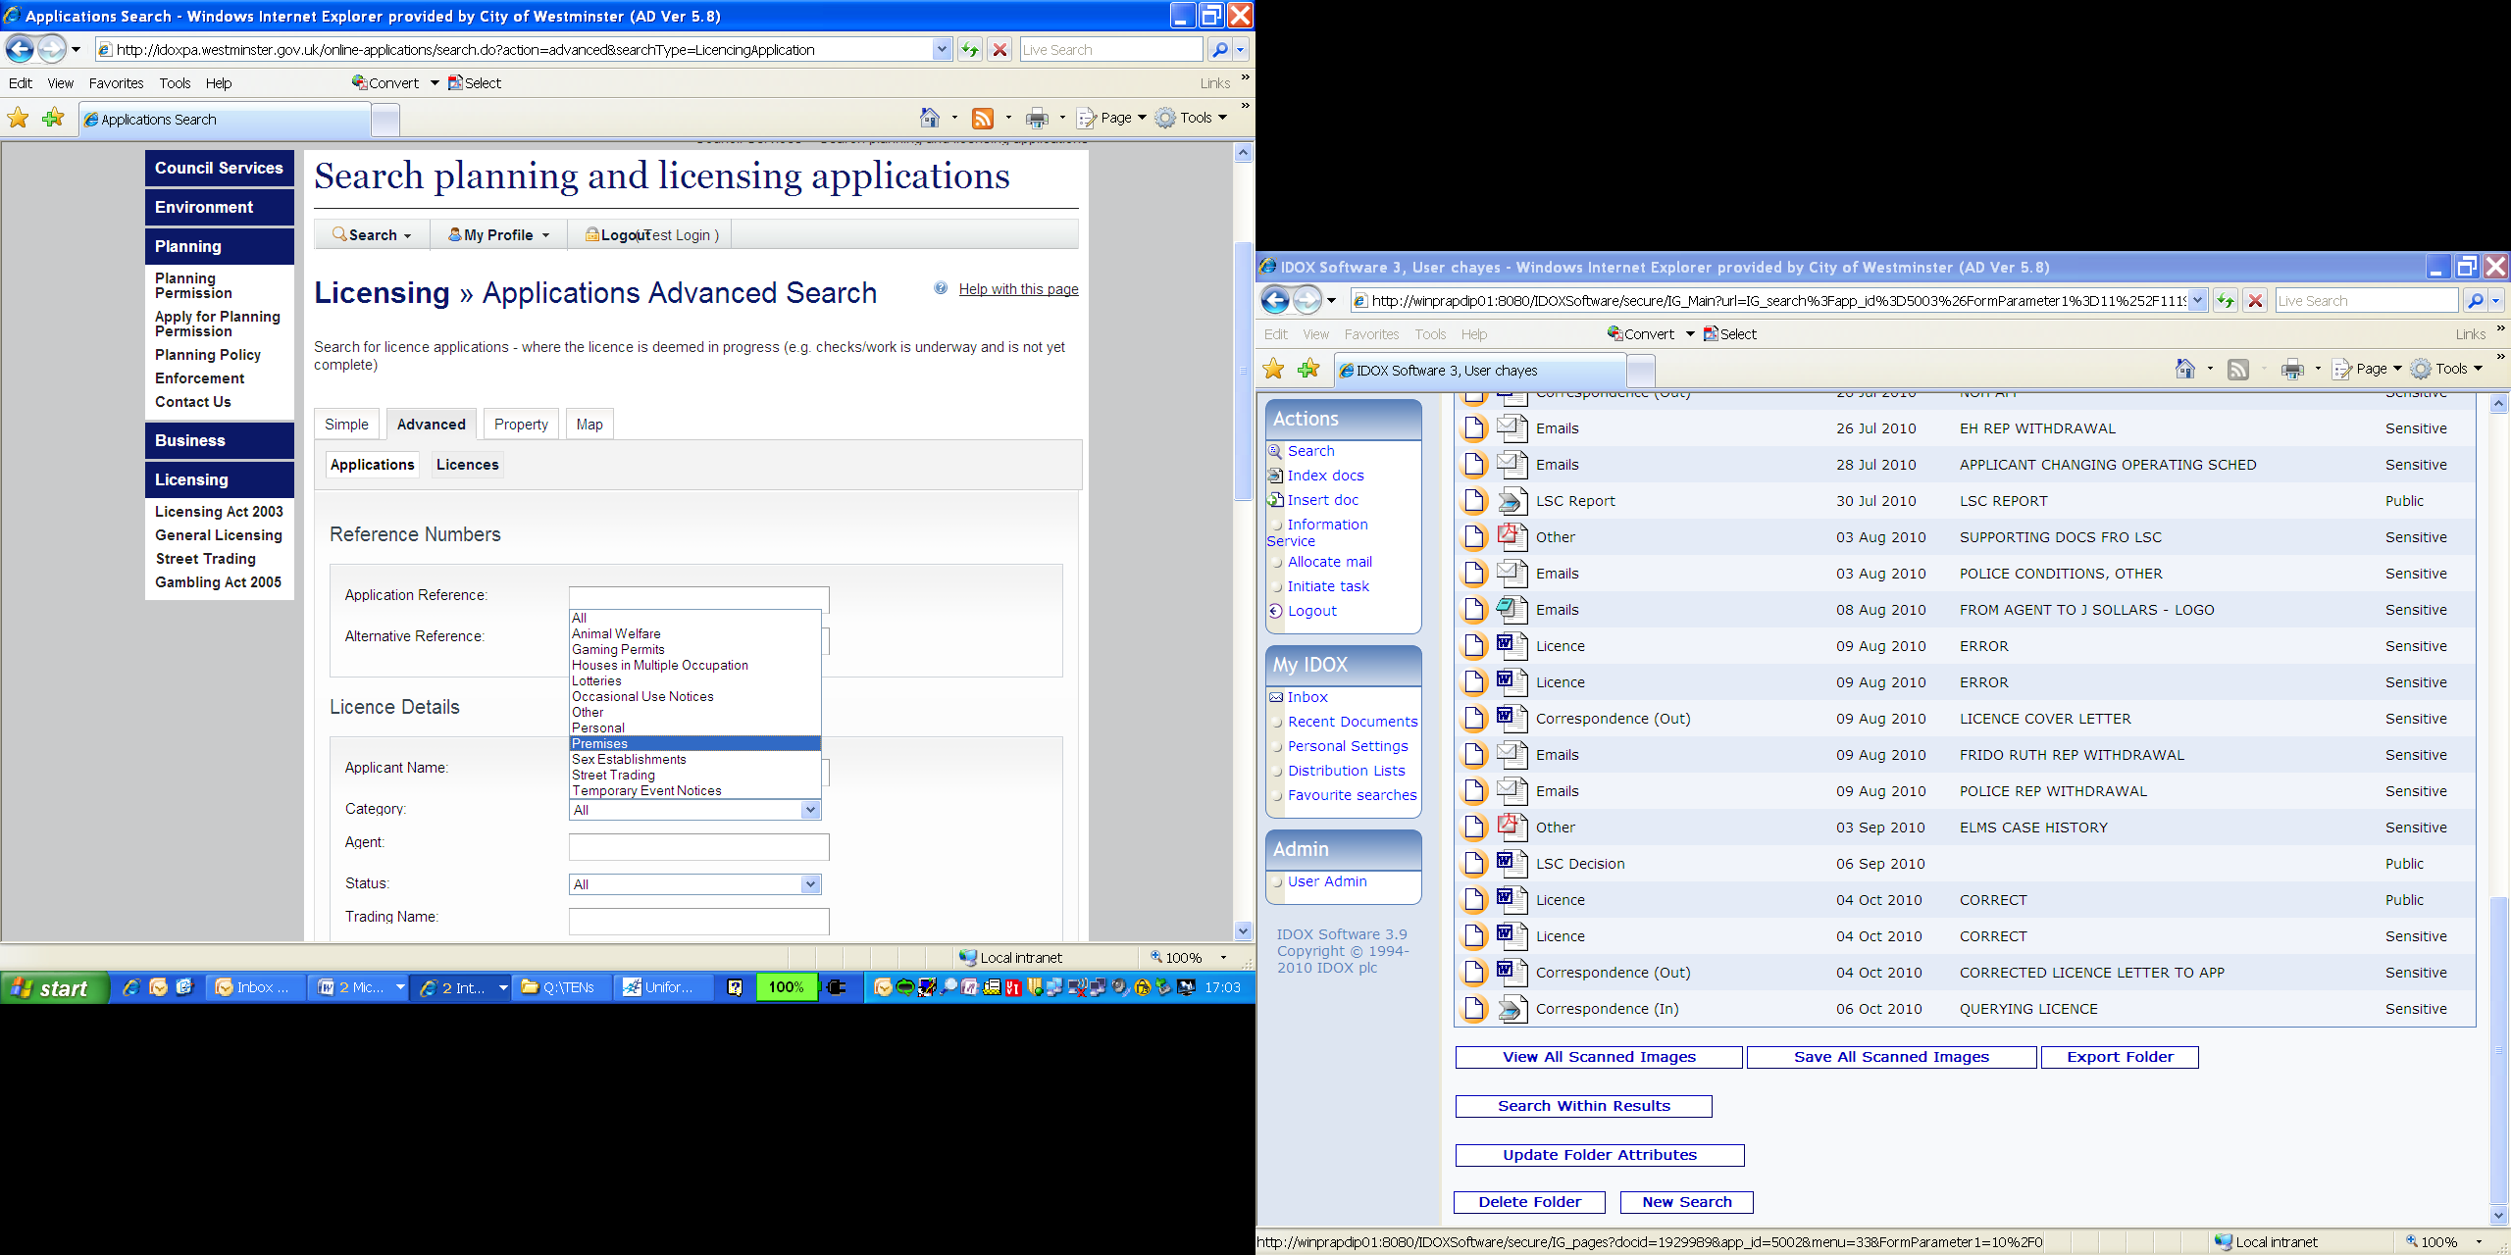
Choose either a search for applications or licences.

You can search by reference number, address or partial address such as a road name, premises name, type of licence, applicant /licensee details or any combination of the above.

- Property Search (Address Search)

Allows you to search the licensing registers by address or by specific street name.

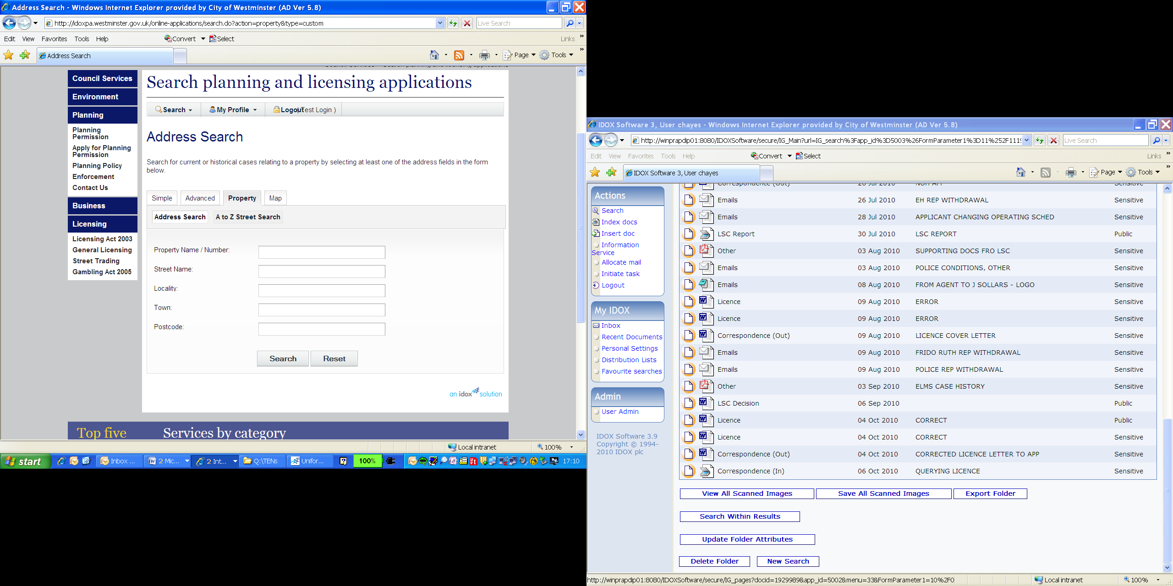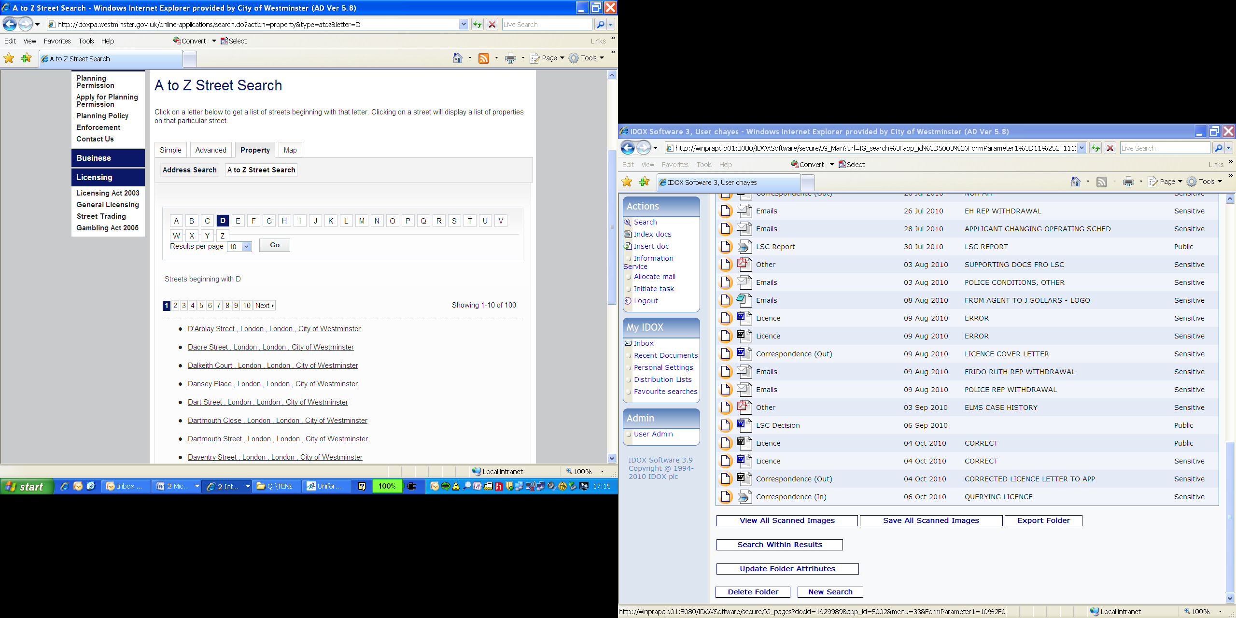

You can opt for an Address Search by clicking on the ‘Address Search’ button, this will allow you to search with part or all of an address.

Or alternatively, click on ‘A to Z Street Search’ simply click on the letter the road name begins with and scroll through the results to find the road/ street you are searching for.

- Map search

This search allows you to view ‘applications’ or ‘licences’ by clicking on the map and finding the area you are interested in. You will need to use the map tools in the top right hand corner of the map screen.

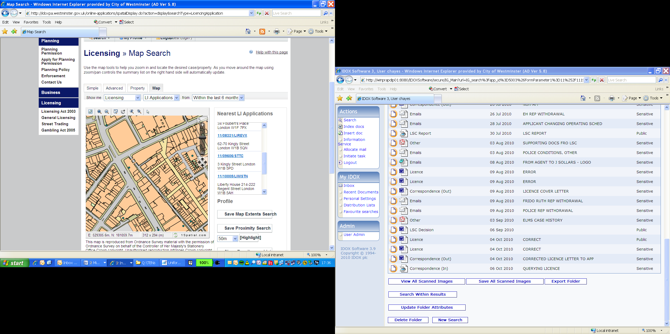
Use the map tools to zoom in and negotiate around the map to locate the area you are interested in.

The search results will appear here.

Finding Documents & Making Comments / representations / objections

To search licensing documents such as application forms, plans and licences or make a comment on a pending application you will need to search for the application using one of the search options.

Once you have retrieved the application you can make a comment (representation, objection or support) by clicking on the ‘Make a Public Comment’ icon. Please remember to tick the option box if you would like a copy of your comments e-mailed to you.

If you would like to view a document related to the application please click on the document tab and click on ‘View Document’ for the item you would like to see.

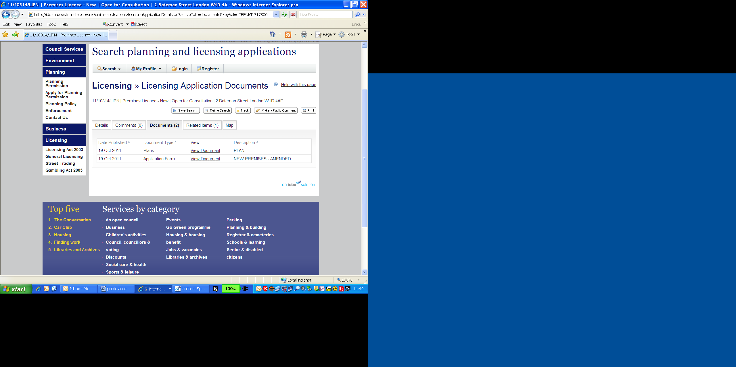
Comments can be submitted by clicking on this button.

All public documents will be viewable on the ‘documents’ tab here.

Tracking applications / Save Searches

(Please note you will need to be registered and logged in to be able to track an application or to save a search)

Once you have found an application you will have a ‘Track’ option in the top right of the screen, if you click on this the application is added to your profile’s tracked applications list. If the status of a tracked application changes an e-mail will be sent to you telling you that there has been a change. You can stop tracking an application at any time from your profile.

Saved searches work in the same way except that rather than getting e-mail updates on an individual application, you will be get an e-mail for the initial search results and then any subsequent changes to that search criteria, for example a new application.
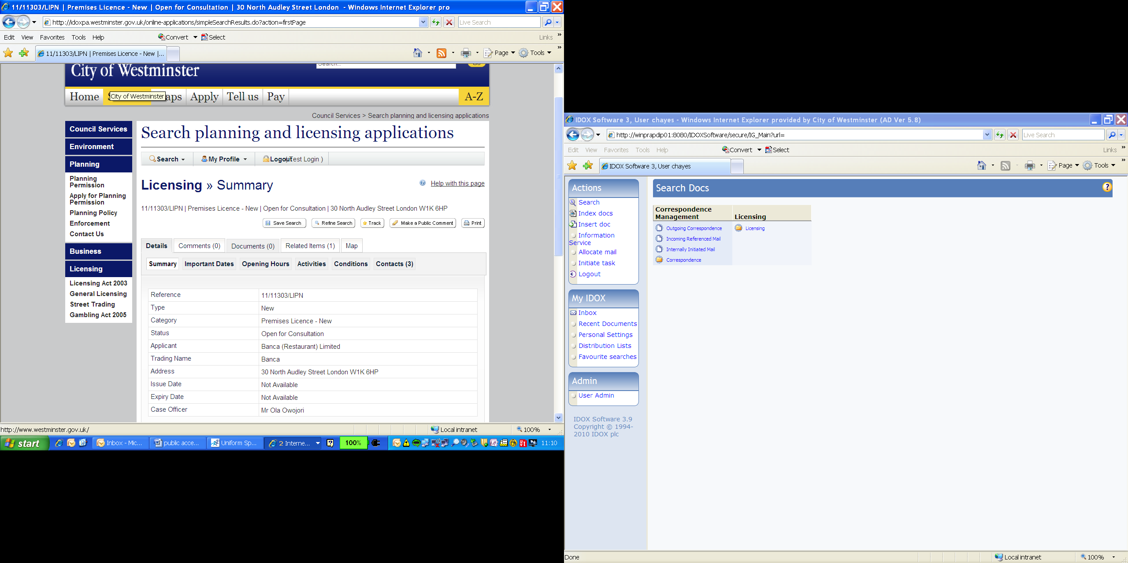
To track an application and receive e-mail updates on the progress of the application click here.
To save a search and receive updates on any applications received within your search perimeters please click here.

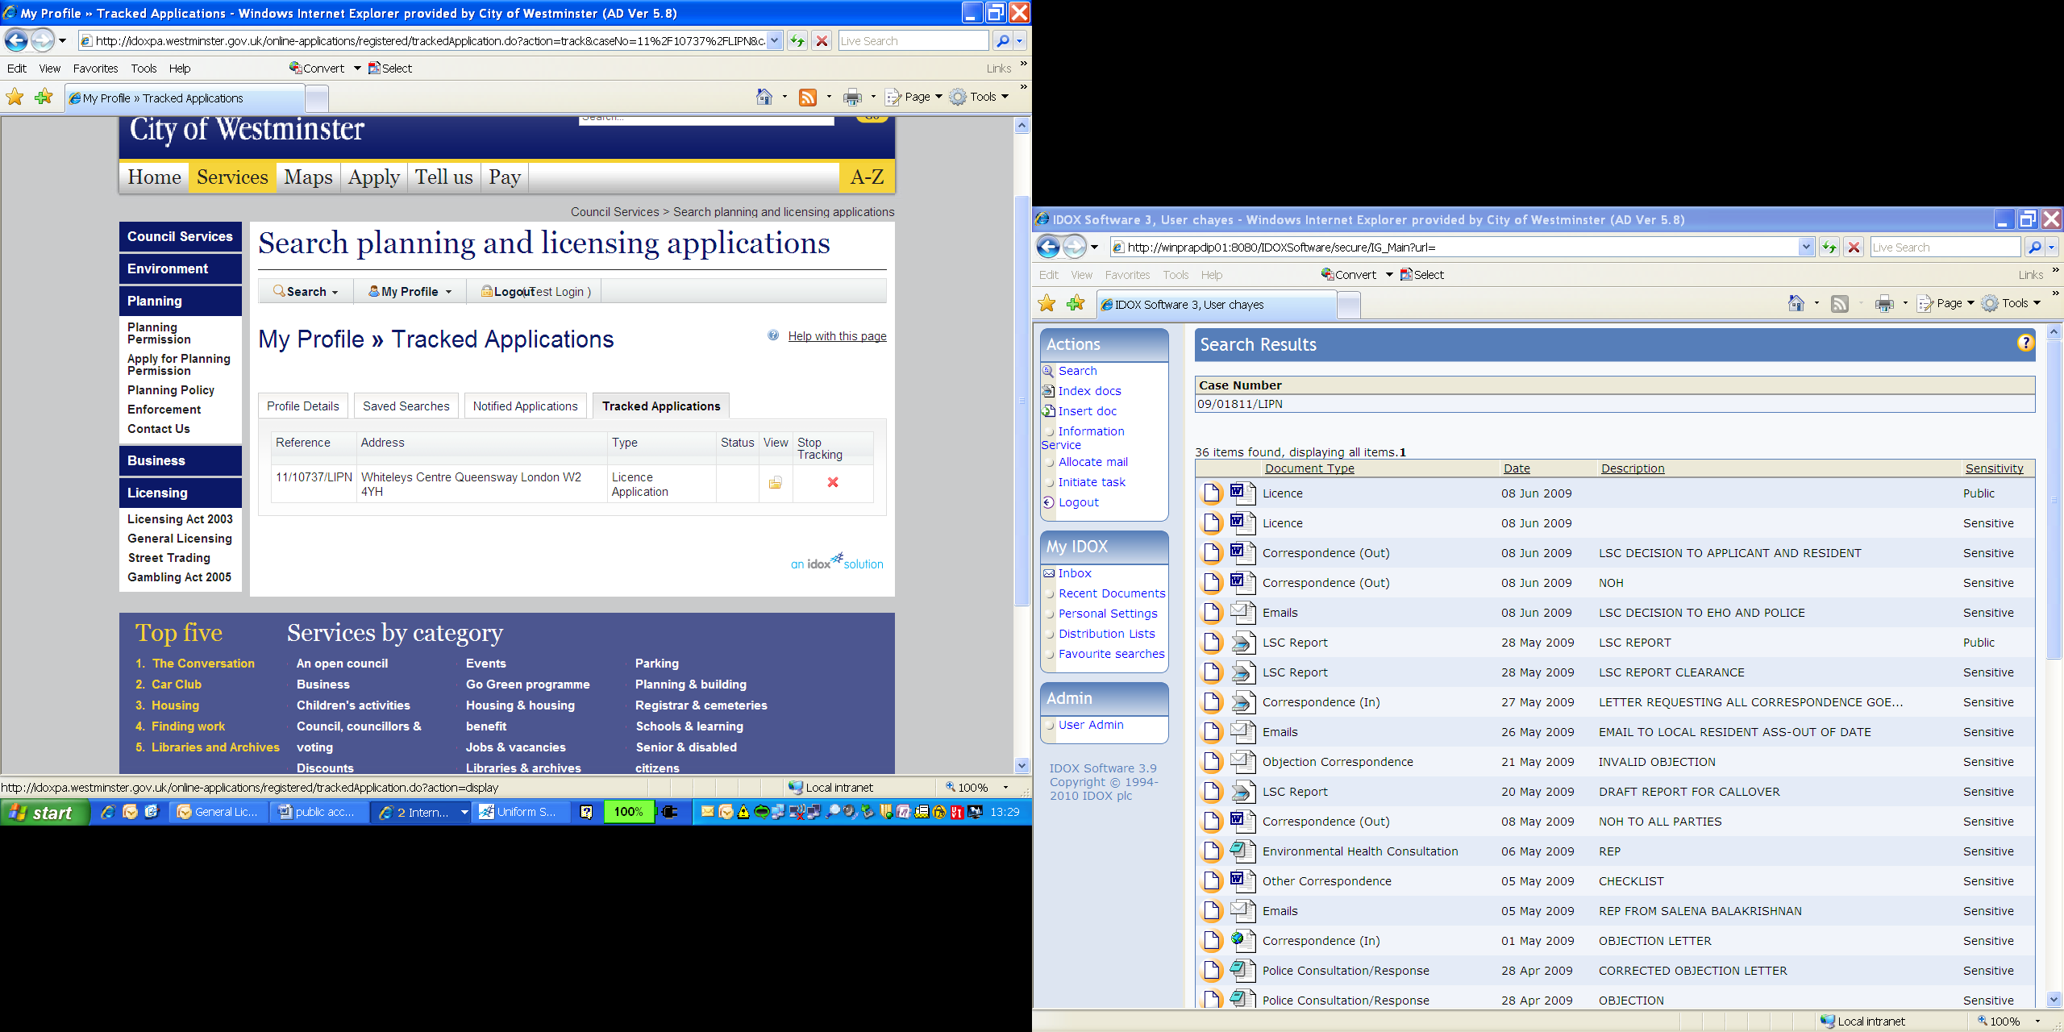
Your tracked application and saved searches will be listed in your profile.

This allows you to check or delete your tracked applications and saves searches.

Please note you have to be logged in to be able to view your profile.

If you have any questions relating to the Licensing Register, please call 020 7641 8549

